|  |
| --- |
|  |

**FPT UNIVERSITY**

|  |  |
| --- | --- |
| Capstone Project Document | |
| **Email marketing platform with Simple Email Service of Amazon Cloud** | |
| Group 3 -JS | |
| **Group members** | Ngô Minh Tấn – SE62503 (Leader)  Nguyễn Lưu Hồng Sơn – SE62414  ~~Đặng Võ Anh Khoa – SE61550~~  Nguyễn Hữu Thắng –SE62447 |
| **Supervisor** | Lâm Hữu Khánh Phương |
| **Ext. Supervisor** | N/A |
| **Project Code** | EMP |

**– Ho Chi Minh City, May 13th, 2019 –**

This page is intentionally left blank

**Table of Contents**

**Table of Contents** 3

A. Introduction 12

1. Project Information 12

2. Introduction 12

3. Current Situation 12

4. Problem Definition 13

5. Proposed Solution 13

5.1. Functions 13

5.2. Advantages and disadvantages 14

6. Functional Requirements 15

6.1. Registered User website and mobile application 15

6.2. Admin website 15

7. Role & Responsibility 16

B. Software Project Management Plan 17

1. Problem Definition 17

1.1. Name of this Capstone Project 17

1.2. Problem Abstract 17

1.3. Project Overview 17

2. Project Organization 21

2.1. Software Process Model 21

2.2. Roles and responsibilities 21

2.3. Tools and Techniques 23

3. Project Management Plan 23

3.1. Product Backlog 23

3.2. Sprint Backlog 23

3.3. Deliverables 23

3.4. All Meeting Minutes 24

4. Coding Convention 24

C. Software Requirement Specification 25

1. User Requirement Specification 25

1.1. Guest requirement 25

1.2. Registered User requirement 25

1.3. Staff requirement 26

1.4. Admin requirement 27

2. System Requirement Specification 27

2.1. External Interface Requirement 27

2.2. System Overview Use Case 29

2.3. List of use case 31

3. Software System Attribute 205

3.1. Usability 205

3.2. Reliability 205

3.3. Availability 206

3.4. Security 206

3.5. Maintainability 206

3.6. Portability 206

3.7. Performance 206

4. Conceptual Diagram 207

D. Software Design Description 210

1. Design Overview 210

2. System Architecture Design 211

2.1. Admin web application: 212

2.2. Registered User web system: 212

3. Component Diagram 213

4. Detailed Description 215

4.1. Class Diagram 215

4.2. Class Diagram Explanation 217

4.3. Interaction Diagram 239

5. Interface 257

5.1. Component Interface 257

5.2. User Interface Design 257

6. Database Design 307

6.1. Entity Relationship Diagram (ERD) 307

6.2. Data Dictionary 309

7. AlgorithEMP 329

7.1. Price suggestion model 329

E. System implementation & Test 335

1. Introduction 335

1.1. Overview 335

1.2. Test Approach 335

2. Database Relationship Diagram 335

2.1. Physical Diagram 335

2.2. Data dictionary 337

3. Test Plan 339

3.1. Features to be tested 339

3.2. Features not to be tested 339

4. System Testing Test Case 340

4.1. Registered User testing case: 340

F. Software User’s Manual 343

1. Installation Guide 343

1.1. Setting up environment at server 343

1.2. Deployment at server side 344

1.3. Deploy web application on server 345

2. User Guide 346

2.1. Web application 346

2.2. Mobile application 346

G. Appendix 357

**List of tables**

Table 1 : Roles and Responsibilities 18

Table 2 - Hardware Requirements for Server 21

Table 3 Hardware requirement for PC 22

Table 4 Hardware requirement for the mobile 22

Table 5 Development Environment - Software Requirement 22

Table 6 Roles and responsibilities 25

Table 7 Tools and techniques 25

Table 8 Deliverables 26

Table 9 <Guest> Login 35

Table 10 <Guest> Register 37

Table 11 <Guest> Search 39

Table 12 <Registered User> Log out 46

Table 13 <Registered User> Search equipment 48

Table 14 <Registered User> Search materials 50

Table 15 <Registered User> Search debris post 53

Table 16 <Registered User> Add subscription 54

Table 17 <Registered User> Remove subscription 56

Table 18 <Registered User> Edit subscription 58

Table 19 <Registered User> Edit profile 59

Table 20 <Registered User> Report another Registered User 61

Table 21 <Registered User> Add construction 63

Table 22 <Registered User> Edit construction 65

Table 23 <Registered User> Delete construction 66

Table 24 <Supplier> View hiring transaction as supplier 69

Table 25<Supplier> Accept pending hiring transaction 71

Table 26 <Supplier> Deny hiring transaction 72

Table 27 <Supplier> Confirm equipment delivering 74

Table 28: <Supplier> Confirm equipment returned 75

Table 29 : <Supplier> Cancel hiring transaction 77

Table 30 <Supplier> Accept request for time extension 79

Table 31 <Supplier> Deny request for time extension 80

Table 32 <Supplier> Post equipment 83

Table 33 <Supplier> Delete equipment 85

Table 34 : <Supplier> Edit equipment 86

Table 35 : <Supplier> Post material 88

Table 36 <Supplier> Post material 90

Table 37 <Supplier> Delete material 91

Table 38 <Supplier> View material transaction 93

Table 39 : <Supplier> Accept pending material transaction 95

Table 40 <Supplier> Deny pending material transaction 96

Table 41 <Supplier> Confirm material delivering 98

Table 42 <Supplier> Cancel material transaction 99

Table 43 <Supplier>View debris transaction 101

Table 44 <Supplier> Bid on debris post 103

Table 45 <Supplier>Confirm preparing debris service 105

Table 46 <Supplier>Confirm working on debris service 106

Table 47 <Supplier>Cancel debris transaction 107

Table 48 <Requester>View hiring transaction 110

Table 49 <Requester>Confirm equipment received 112

Table 50 <Requester>Request equipment 114

Table 51 <Requester>Cancel hiring transaction 116

Table 52 <Requester>Request to extend hiring time 118

Table 53 <Requester>Cancel time extension request 119

Table 54 <Requester>Return equipment 122

Table 55 <Requester>Feedback hiring transaction 123

Table 56 <Requester>View material transaction 125

Table 57 <Requester>Send material request 127

Table 58 <Requester>Cancel material transaction 129

Table 59 <Requester>Confirm material received 130

Table 60 <Requester>Feedback material transaction 131

Table 63 <Requester>Publish debris post 133

Table 64 <Requester>Edit debris post 135

Table 65 <Requester>Close debris post 136

Table 66 <Requester>Delete debris post 138

Table 67 : <Requester>Edit debris post 139

Table 68 <Requester>Accept debris bid 141

Table 69 Requester>Cancel debris transaction 143

Table 70 <Requester>Confirm debris transaction finished 144

Table 71 <Requester>Feedback debris transaction 146

Table 72 <Scheduler>Check outdate equipment 147

Table 73 <Scheduler>Check subscription matched 149

Table 74 <Scheduler> Train price suggestion model 151

Table 75 <Staff>Verify Registered User 154

Table 76 <Staff>Verify Registered User 155

Table 77 <Staff>Verify Registered User 156

Table 78 <Staff>Verify report 158

Table 79 <Staff>Edit material 159

Table 80 <Staff>Edit equipment 161

Table 81 <Staff>Change password 162

Table 82 <Staff>Adjust hiring transaction 164

Table 83 <Staff>Adjust material transaction 165

Table 84 <Staff>Adjust debris transaction 167

Table 85 <Staff>Send custom notification 168

Table 86 <Staff>View equipment analytics 169

Table 87 : <Staff>View material analytics 171

Table 88 <Staff>View debris analytics 172

Table 89 <Admin>Add staff 175

Table 90 <Admin>Delete staff 176

Table 91 <Admin>Add equipment category 178

Table 92 <Admin>Edit equipment category 179

Table 93 <Admin>Migrate equipment category 181

Table 94 <Admin>Delete equipment category 182

Table 95 <Admin>Add equipment type 183

Table 96 <Admin>Edit equipment type 185

Table 97 <Admin>Delete equipment type 186

Table 98 <Admin>Add equipment type additional fields 188

Table 99 <Admin>Edit equipment type additional fields 189

Table 100 Conceptual Diagram Dictionary 211

Table 101 <Fields> Login 259

Table 102 <Buttons/Hyperlinks> Login 259

Table 103 <Fields> Sign Up 261

Table 104 <Buttons/Hyperlinks> Sign Up 261

Table 105 <Buttons/Hyperlinks> Main menu 262

Table 106 <Buttons/Hyperlinks> Equipment menu 263

Table 107 <Buttons/Hyperlinks> Material menu 264

Table 108 <Buttons/Hyperlinks> Debris menu 264

Table 109 <Buttons/Hyperlinks> User menu 265

Table 110 <Fields> Equipment search 266

Table 111 <Buttons/Hyperlinks> Search equipment 266

Table 112 <Fields> Post new equipment step 1 267

Table 113 <Buttons/Hyperlinks> Post new equipment step 1 268

Table 114 <Fields> Post new equipment step 2 268

Table 115 <Buttons/Hyperlinks> Post new equipment step 2 269

Table 116 <Fields> Post new equipment step 3 269

Table 117 <Buttons/Hyperlinks> Post new equipment step 3 269

Table 118 <Fields> Post new equipment step 2 270

Table 119 <Buttons/Hyperlinks> View and delete equipment 271

Table 120 <Fields> Edit equipment 272

Table 121 <Buttons/Hyperlinks> Edit equipment 273

Table 122 <Fields> Manage equipment transactions 274

Table 123 <Buttons/Hyperlinks> Manage equipment transactions 274

Table 124 <Fields> Manage equipment subscriptions 275

Table 125 <Buttons/Hyperlinks> Manage equipment subscriptions 276

Table 126 <Fields> Login 290

Table 127 <Buttons/Hyperlinks> Login 290

Table 128 <Buttons/Hyperlinks> Main menu 291

Table 129 <Buttons/Hyperlinks> Equipment menu 292

Table 130 <Buttons/Hyperlinks> Material menu 293

Table 131 <Buttons/Hyperlinks> Debris menu 294

Table 132 <Buttons/Hyperlinks> Report menu 294

Table 133 <Fields> Dashboard 296

Table 134 <Buttons/Hyperlinks> Dashboard 296

Table 135 <Fields> Manage Staff 298

Table 136 <Buttons/Hyperlinks> Manage Staff 298

Table 137 <Fields> Manage Registered User 300

Table 138 <Buttons/Hyperlinks> Manage Registered User 300

Table 139 <Fields> Manage Equipment Category 301

Table 140 <Buttons/Hyperlinks> Manage Equipment Category 302

Table 141 <Fields> Manage Equipment Type 303

Table 142 <Buttons/Hyperlinks> Manage Equipment Type 304

Table 143 <Fields> Manage Equipment 306

Table 144 <Buttons/Hyperlinks> Manage Equipment 306

Table 145 <Fields> Manage Hiring Transaction 308

Table 146 <Buttons/Hyperlinks> Manage Hiring Transaction 308

Table 147 Entity Relationship Diagram Dictionary 312

**List of Figures**

Figure 1 - Scrum Framework 23

Figure 2: <Guest> Overview use case 33

Figure 3 <Guest> Login 33

Figure 4 Conceptual Diagram 209

Figure 5 System Architecture diagram 213

Figure 6 Component Diagram - Registered User Web Api 215

Figure 7 Component Data Dictionary 217

Figure 8 Class Diagram 218

Figure 9 Class Diagram Dictionary 222

[Figure 10 Sequence Diagram - Search equipment 242](https://d.docs.live.net/fe447eae7a2d9c8b/Capstone/reports/Report-full.docx#_Toc7065941)

[Figure 11 Sequence Diagram - Login 243](https://d.docs.live.net/fe447eae7a2d9c8b/Capstone/reports/Report-full.docx#_Toc7065942)

[Figure 12 Sequence Diagram - Check Subscription 244](https://d.docs.live.net/fe447eae7a2d9c8b/Capstone/reports/Report-full.docx#_Toc7065943)

Figure 13 Sequence Diagram - Post equipment 245

Figure 14 Sequence Diagram - Request equipment 246

[Figure 15 Sequence Diagram - Chang hiring status 247](https://d.docs.live.net/fe447eae7a2d9c8b/Capstone/reports/Report-full.docx#_Toc7065946)

Figure 16 Sequence Diagram - Checkout Materials 248

Figure 17 Sequence Diagram - Publish Debris Post 249

Figure 18 Sequence Diagram - Bid on Debris Post 250

Figure 19 Sequence diagram - Verify Registered User 255

[Figure 20 Sequence diagram - Add staff 256](https://d.docs.live.net/fe447eae7a2d9c8b/Capstone/reports/Report-full.docx#_Toc7065951)

Figure 21 Sequence diagram - Add equipmen type 257

[Figure 22 Edit equipment type 258](https://d.docs.live.net/fe447eae7a2d9c8b/Capstone/reports/Report-full.docx#_Toc7065953)

Figure 23 Login 259

Figure 24 Entity Relation Diagram 310

**Figure 25 Linear regression plot - from Wikipedia** 332

**Figure 26 Gradient Descent Plot** 334

Figure 27: Physical Diagram 338

Figure 28: Data Dictionary 341

# Introduction

## Project Information

* Project name:  **Email marketing platform with Simple Email Service of Amazon Cloud**
* Project Code: **EMP**
* Product Type: **Website Application**
* Start Date: **May 13th, 2019**
* End Date: **July 24th, 2019**

## Introduction

This document introduce a solution for email marketing. At its most basic level, email marketing is the use of email to promote your business. It is used to cultivate relationships with potential customers, keep current customers informed and updated on your brand, offer coupons to encourage customer loyalty, and more.

It is a direct form of marketing, similar to marketing through snail mail, but email marketing is much more efficient for your wallet and for the environment since it’s totally paperless.

Email marketing can be used to build trust with customers over time to turn them into repeat customers. It is also an effective way to keep your customers informed about new sales or promotions you are running. People want to stay informed about your brand, and email marketing is one of the best ways to stay engaged with that audience.

Because of that we have built a software called Mindsending. Unlike others email marketing applications on the market, we not only bring every main function of the email marketing application but also help the user by supporting them the drawing of BPMN (Business Process Modeling Notation) which can be applied to the system so that they can manage and track their work flow in the easiest way.

Beside that our web system uses Amazon SES which will help you for sending a large amount of email from sender to many recipients without sending spam mails, porn mails or in-appropriate content.

## Current Situation

- Email marketing is the act of sending a commercial message, typically to a group of people, using email. Email marketing is significantly cheaper and faster than traditional mail, mainly because with email, most of the cost falls on the recipient. Email marketing carries the benefit of allowing marketers to identify returns on investment and measure and improve efficiency.

- But email marketing also has some of disadvantages: spam emails, porn emails, in-appropriate content in the message which send to the customers.

## Problem Definition

Below are disadvantages of current situation:

* **Traditional marketing costs are very high,** sales companies spend a lot of money on 30s advertising on television or on other media such as newspapers and flyers.
* **Sending traditional emails is easy to send your mail to the spam mailbox,** making the approach to customers more restrictive.
* **Others email marketing applications on the market, it is only for users to create a simple pure automated email** with a non-general look that will make it difficult for new entrants to set up an email marketing.

## Proposed Solution

Our proposed solution is to build a system called MindSending (EMP) to resolve the current situation by helping people has a more general view of the system to automatically send emails to customers by supporting the drawing of BPMN (Business Process Modeling Notation) and then apply to the system so that they can manage and track their work flow in the convenient way.

The EMP system includes two web applications with BPMN drawing tool.

### Functions

* Administrator system (Web application):
  + **Manage Report**: Admin or staff can manage, adjust information with high authority actions.
  + **Manage account**: Admin or staff can check and verify sensitive information, account profile information.
  + **Manage sever**: Admin can view overall sever and manage sever with high authority actions.
* Client applications (Web application):
  + **Manage own account:** The customer has an overview of the account information….
  + **Manage report:** The customer can view report generated from the system by date, month, year.
  + **Manage contact:** When a contact is brought into the system, the customer can add, delete, edit contact and can export contact lists.
  + **Manage group:** Customers can categorize contacts into groups to facilitate contact entry into the appropriate sending email list.
  + **Manage templates:** Customers can add a new template or edit an existing template of the system.
  + **Manage campaign:** Customers can add a new campaign or edit an existing campaign of the system.
  + **Draw BPNM model:** Customers can draw a BPNM model to set up automation campaign.

### Advantages and disadvantages

The advantages and disadvantages of the proposed solution:

* Advantages
  + **Easy for managing and review:** Managing all workflow automation email marketing through BPMN model. Customer can drag/drop object from BPMN drawing tool.
  + **Helping for using contact database effectively through contact and group system EMP:** Help customers categorize customers according to each status.
* Disadvantages:
  + **Can not satisfy all demands:** Marketing is a very flexible and complicated field and there are special business cases that the system cannot fit. Staff involvement may be required in order to resolve these special situations.

## Functional Requirements

Function requirements of the system are listed as below:

### Email marketing website

* Customer can login
* Customer can logout
* Customer can register
* Customer can view account information
* Customer can edit account information
* Customer can search for contact with filter and sorting
* Customer can manage contact in the system
* Customer can manage and change their contact status
* Customer can search for group contact with filter and sorting
* Customer can manage group contact
* Customer can import contact
* Customer can edit contact
* Customer can add new template
* Customer can edit templates suitable for work purposes
* Customer can add new campaign
* Customer can edit campaign
* Customer can send campaign
* Customer can add appointment
* Customer can add new BPNM model
* Customer can edit BPNM model
* Customer can view analysis report by date, month, year

### Admin website

* Admin can manage report
* Admin can manage all accounts on the system
* Admin can manage sever

## Role & Responsibility

|  |  |  |  |  |
| --- | --- | --- | --- | --- |
| **No** | **Full Name** | **Role** | **Position** | **Contact** |
| 1 | Lâm Hữu Khánh Phương | Project Manager | Supervisor |  |
| 2 | Ngô Minh Tấn | Developer | Leader |  |
| 3 | Nguyễn Lưu Hồng Sơn | Developer | Member |  |
| 4 | ~~Đặng Võ Anh Khoa~~ | ~~Developer~~ | ~~Member~~ |  |
| 5 | Nguyễn Hữu Thắng | Developer | Member |  |

Table 1 : Roles and Responsibilities

# Software Project Management Plan

## Problem Definition

### Name of this Capstone Project

* Official name: Email marketing platform with Simple Email Service of Amazon Cloud
* Vietnamese name: Ứng dụng khởi tạo email tiếp thị kết hợp dịch vụ email của Amazon
* Abbreviation: EMP

### Problem Abstract

This project concentrates on creating an automation email marketing. It is called Mindsending (EMP). EMP is to assist customer for managing and initiating an automation email marketing.

In marketing, planning a marketing plan that suits the needs of customers is a central issue. Use email that has been collected effectively and can be reused.

The Mindsending web application supports customer an optimal solution for that problem, providing a BPNM model for easy manage and create a workflow.

### Project Overview

#### Current Situation

Below are the problems encountered in this project:

* **Limited time and human resource.** The team only has 4 members and 13 weeks to execute the project from requirement analytics, design, implement and testing.
* **Lack of business view.** Team members’ major is Software engineering, leading to little experience in general business fields, especially in the construction business field. Therefore, research and training effort would be made to adjust and improve the business model.
* **Lack of experience**. Team members do not have much experience in applying new technology into real projects. There would be new probleEMP arise that require research time and expertise.
* **Schedule conflict.** Team members have different schedule arrangement and lack of co-working time, leading to lack of synchronization of the team.
* **Lack of UX/UI skills.** As developers, the team do not have much knowledge in graphics design and user experience designing, which is a critical factor for a successful C2C product (customer-to-customer product)

#### The Proposed System

According to the recent trend in e-commerce, email marketing is a promising field that can solve access customer’s problem. Therefore, applying that model with necessary modification would be a possible solution.

The basic idea is that we create an email marketing platform with Simple Email Service of Amazon Cloud. We provide a website for end user (customer) to use the system. We also have an admin website to control the system with high authority.

#### Boundaries of the System

* The language of the system is English
* (pending)

#### Future Plans

* Current system can only support admin to manage equipment. We design the system to provide analytic views for admin:
  + Admin can view statistics and visualized graph about transaction process
  + Admin can view strategic information about equipment trends, hiring trends, Registered User needs trends
* Current system can only suggest price to Registered User based on equipment type. We design the system to support data for further machine learning features:
  + Suggest equipment price based on equipment name, location, time
* Current system can only provide delivery status to delivery management. We design the system to support more feature to delivery phase:
  + Support direction and route guidance for delivery
  + Support delivery time estimate based on city, time, traffic

#### Development environment

##### Hardware requirements

For server

|  |  |  |
| --- | --- | --- |
| Hardware | Minimum Requirement | Recommended |
| Internet Connection | Cable, Wi-Fi (8 Mbps) | Cable, Wi-Fi (50 Mbps or more) |
| Operation System | XP, Vista, 7, 10, Window Server 2008, Linux | 10, Window server 2008 |
| Computer Processor | Intel® Xeon ® 1.4GHz | Intel® Xeon ® Quad Core (12M Cache, 2.50 GHz) |
| Computer memory | 4GB RAM | 32 GB RAM or more |
| Storage space | 1GB | 5GB or more |

Table 2 - Hardware Requirements for Server

For PC

|  |  |  |
| --- | --- | --- |
| PC | Minimum Requirements | Recommended |
| Internet Connection | Cable, Wi-Fi (4 Mbps) | Cable, Wi-Fi (8 Mbps) |
| Operating System | Window 7 | Window 7 or more. |
| Computer Processor | Intel® Core i3 1.4GHz | Intel® Core i5 2.50GHz |
| Computer Memory | 1GB RAM | 2GB RAM or more |
| Web Browser | Chromes (v42 or higher) | Chrome latest stable version |

Table 3 Hardware requirement for PC

##### Software requirement

|  |  |  |
| --- | --- | --- |
| Software | Name / Version | Description |
| Operation System | Windows Server 2014 | Operating system and platform for development |
| Environment | Java EE 8.0, Node v10, npm v6 | Specification for developing web application |
| Modeling tool | StarUML, Draw.io | Used to design diagram |
| IDE | Intellij IDEA 2019.1.5, Visual Studio Code 1.27.2 | Programming tools |
| DBEMP | MYSQL 8.0 | Used to create & manage the database for system |
| Source control | Git (Github server) | Used for source control |
| Web browser | Chrome 69 or above | Testing browser |

Table 4 Development Environment - Software Requirement

## Project Organization

### Software Process Model

This project is developed using Scrum model – part of an agile framework for Software development project. Scrum model is chosen because of the following reasons:

* Scrum is the most suitable model for small and medium project, and we only have 4 members
* The term “machine learning” is new to the team and there would be many trial-and-error tests with the system design before applying to the official release
* There are many new technologies that team members have to learn and develop at the same time, so SCRUM would allow us to do that
* The business model may not be fully tested in real market condition so changes are highly possible. Using Scrum team members can adapt to changes better

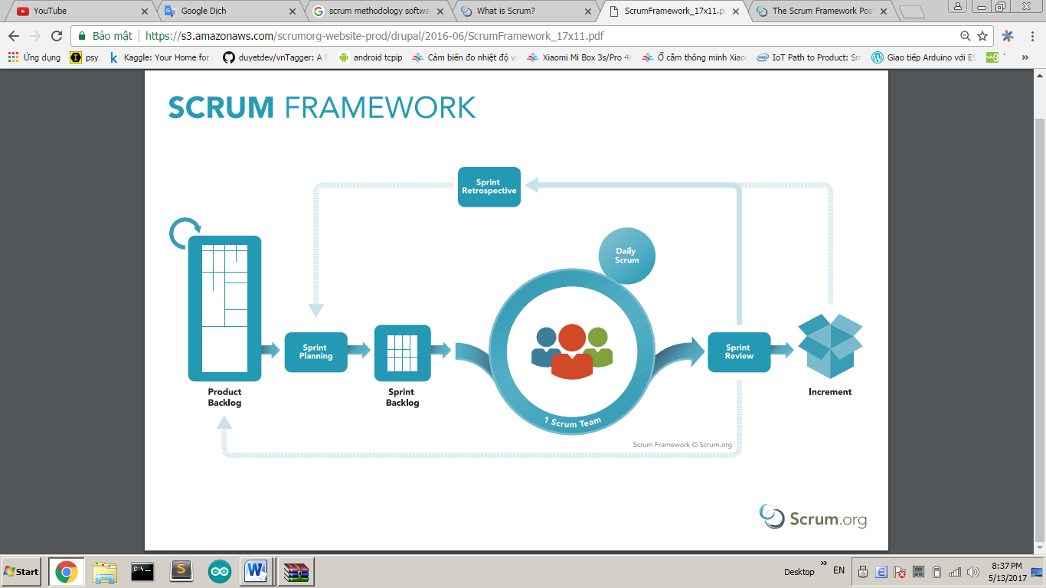

Figure 1 - Scrum Framework

### Roles and responsibilities

|  |  |  |  |
| --- | --- | --- | --- |
| No | Full name | Role in Group | Responsibilities |
| 1 | Ngô Minh Tấn | Product Owner | * Specify user requirement * Control the development process * Give out technique and business analysis support |
| 2 | Nguyễn Hữu Thắng | Scrum Master | * Managing project * Designing databases * Clarifying requirements * Prepare documents * GUI Design * Create test plan * Coding * Testing * Arrange Meeting * Risk Management |
| 3 | Nguyễn Lưu Hồng Sơn | Scrum team member | * Clarifying requirements * Preparing documents * Mobile GUI Design * Coding * Testing |

Table 6 Roles and responsibilities

### Tools and Techniques

|  |  |
| --- | --- |
| Tool/Technique | Name |
| Front-end | HTML, CSS, JavaScript, jQuery, ReactJs |
| Back-end | JavaEE, Spring, JPA, Hibernate |
| IDE | IntelliJ IDEA 17.2, Visual Studio Code |
| DBEMP | MySQL |
| Source Control | Git, Github |
| Modelling tool | StarUML, Draw.io |

Table 7 Tools and techniques

## Project Management Plan

### Product Backlog

Product Backlog could be found [here.](https://drive.google.com/open?id=1hJ2loRGJDPmh-D2Zm1oSJTu9u1qBt99ybJAj1JLJSt0)

### Sprint Backlog

Sprint Backlog can be found [here](https://docs.google.com/spreadsheets/d/1ei8C6OGqnKYWK0I5HX1T0Bcu-IQfVVulU_9_QmHVhEY/edit?usp=sharing)

### Deliverables

|  |  |  |
| --- | --- | --- |
| No | Deliverable | Note |
| 1 | Introduction, Entity Relationship Diagram, Business model detail, | Sprint 1 |
| 2 | Use case Overview, UI for mobile application, Conceptual Diagram, First deployment | Sprint 2 |
| 3 | Class Diagram, Physical Diagram, UI for Website Admin, Implement Search equipment | Sprint 3 |
| … |  |  |

Table 8 Deliverables

### All Meeting Minutes

All sprint meeting minutes could be found [here](https://drive.google.com/open?id=1LIwLFeSkVkFuURBqeYgy2I-vJnobL-u3).

## Coding Convention

Summary:

* Naming Convention:
  + Variable names should be short yet meaningful. The choice of a variable name should be designed to indicate to the casual observer the intent of its use.
  + Methods should be verbs, in mixed case with the first letter lowercase, with the first letter of each internal word capitalized.
* Indentation:
  + One declaration per line is recommended since it encourages commenting.
  + In absolutely no case should variables and functions be declared on the same line.
  + Do not put different types on the same line.
* Declarations Convention:
  + One declaration per line is recommended since it encourages commenting.
  + Using Java Code Convention from:

<http://www.oracle.com/technetwork/java/codeconvtoc-136057.html>

# Software Requirement Specification

## User Requirement Specification

### Guest Requirement

***Guest*** *is a person who doesn’t have access to the system. Guest can use some*

*functions in the system. To use all functions, guest must login. These are some*

*functions that guest can use*:

* Login.
* Register.

### User requirement

***User*** *is a guest who logged into the system with user’s role. There are some functions that user can use:*

* Manage own account
* Manage report:

-View report

-Analysis report

* Manage contact:

-Add contact

-Delete contact

-Edit information of contact

-Import list contact

* Manage group:

-Add contact to group

-Delete group

-Edit group

-Search group

-Create group

* Manage templates:

-Add formatted template

-Edit inside template

-Copy template

* Manage campaign:

-Add campaign

-Edit campaign

-Copy campaign

* Manage appointment:

-Add appointment

* Draw BPNM model:

-Add BPNM

-Edit BPNM

-Delete BPNM

* Manage embed form

-Add Embeded form

-Copy script

### Admin requirement

***Admin*** *is an authorized user has permission to log in to the system. An admin has higher authority than user and can do whatever a user can. In addition, an admin can do the following functions:*

* Admin can manage account
* Admin can manage report
* Admin can manage sever

## System Requirement Specification

### External Interface Requirement

#### User Interface:

* GUI should be simple, clear, intuitive, and reminiscent.
* The interface design is an iterate process includes: design, sketching, prototyping, user assessment.
* The language for User Interface is English

#### Hardware Interface

* Mobile Device
* Desktop PC or Laptop

#### Software Interface

* Web application: work with browsers Firefox (v52 or higher), Chromes (v28 or higher), Internet Explorer (v10 or above) or with any web browser that supports HTML5 & CSS3.
* Mobile application: iOS (9.0 or higher)

#### Communication Protocol

* Use HTTP protocol 1.1 for communication between the web browser and the web server.

### 2.2. System Overview Use Case

Figure 1: System overview use case



### List of use case

#### <Guest> Overview Use Case

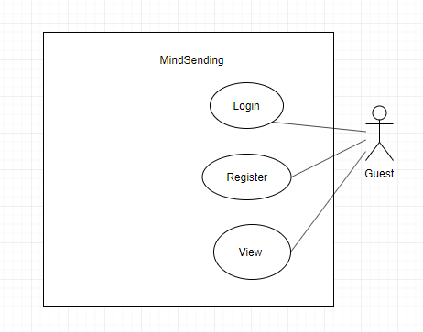

Figure 2: <Guest> Overview use case

##### <Guest> Login

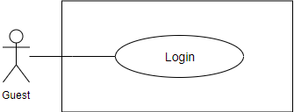

Figure 3 <Guest> Login

**Use Case Specification**

|  |  |  |  |
| --- | --- | --- | --- |
| **USE CASE – EMP_UC_01** | | | |
| **Use Case No.** | **EMP_UC_01** | Use Case Version | 1.1 |
| **Use Case Name** | Login | | |
| **Author** | Nguyễn Hữu Thắng | | |
| **Date** | 15/07/2019 | **Priority** | Normal |
| **Actor:**   * Guest   **Summary:**   * This use case allows user to login to the system.   **Goal:**   * User can login to the system   **Trigger:**   * User send the login command. * User clicks on “Sign In” button   **Precondition:**   * User is viewing the login screen   **Post Conditions:**   * Success: User login to the system successfully * Fail: Show error messages   **Main Success Scenario:**   |  |  |  | | --- | --- | --- | | Step | Actor Action | System Response | | 1 | User go to the login view | The system requires the following input from User includes:   * Username: text, required * Password: text, required | | 2 | User inputs information. |  | | 3 | User sends command to login | The system show message that the user has logged in successfully  [Exception 1] |   **Exception 1:**   |  |  |  | | --- | --- | --- | | **Step** | **Cause** | **System Response** | | 1 | No internet connection | System shows message the "Please check your connection" when the internet is lost. |   **Relationship:** N/A.  **Business rule:**   * User password character is secured and hidden with special character * The system generates an access token * The system generates a refresh token * System can use access token to verify identity without reenter username and password again * Refresh token can be used to retrieve new access token with no username or password needed * Access token have expiration time of 15 mins * Refresh token has expiration time of 90 days * Refresh token and access token is signed with RSA256 algorithm * Refresh token and access token also contain at least following information:   + Username   + User id   + Expire time   + Created time   + Signature for security * User is required a new refresh token if password changed or refresh token is expired | | | |

Table 1 <Guest> Login

##### <Guest> Register

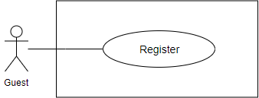

Figure 4: <Guest> Register

**Use Case Specification**

|  |  |  |  |
| --- | --- | --- | --- |
| **USE CASE - EMP_UC_02** | | | |
| **Use Case No.** | EMP_UC_02 | Use Case Version | 1.1 |
| **Use Case Name** | Register | | |
| **Author** | Nguyễn Hữu Thắng | | |
| **Date** | 15/07/2019 | **Priority** | Normal |
| **Actor**:   * Guest   **Summary**:   * This use case allows user to register to the system.   **Goal**:   * User can register to the system   **Trigger**:   * User send the register command. * User clicks “Sign up”   **Precondition**:   * User is viewing the register screen   **Post Conditions:**   * Success: User register to the system successfully * Fail: Show error messages   **Main Success Scenario:**   |  |  |  | | --- | --- | --- | | **Step** | **Actor Action** | **System Response** | | 1 | User go to the guess view | The system requires the following input from User includes:   * Username: text, required * Password: text, required * Confirm password: text, required * Name: text, required * Email: text, required * Phone: text as number, required * Profile image: image, required | | 2 | User inputs information. |  | | 3 | User sends the command to register | The system show message that the user has registered successfully  [Exception 1] |   Exception 1:   |  |  |  | | --- | --- | --- | | **Step** | **Cause** | **System Response** | | 1 | No internet connection | System shows message the "Please check your connection" when the internet is lost. |   **Relationship**: N/A.  **Business** rule:   * User password must not be saved directly plain text, and must be hashed * The system validates user input with the following constraints:   + Username: unique   + Phone number: number format   + Email: as an email format   + The confirm password matches the password | | | |

Table 2 <Guest> Register

#### <Registered User> Overview Use Case

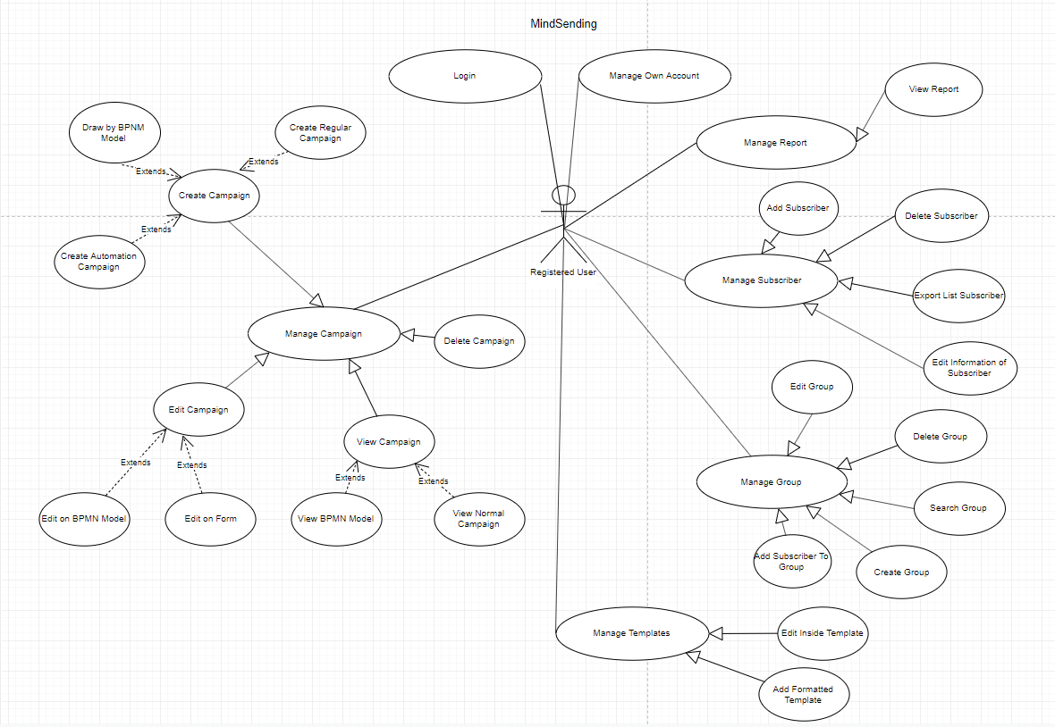

Figure 8: <Registered User>Overview use case

##### <Registered User> Logout

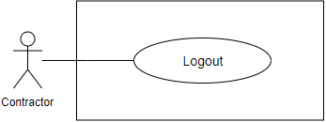

Figure 9: <Registered User> Logout

**Use Case Specification**

|  |  |  |  |
| --- | --- | --- | --- |
| **USE CASE - EMP_UC_03** | | | |
| **Use Case No.** | **EMP_UC_03** | **Use Case Version** | 1.1 |
| **Use Case Name** | Logout | | |
| **Author** | Nguyễn Hữu Thắng | | |
| **Date** | 15/07/2019 | **Priority** | Normal |
| **Actor:**   * Registered User   **Summary:**   * This use case allows user to logout to the system.   **Goal:**   * User can logout from the system   **Trigger:**   * User send a logout command.   **Precondition:**   * User is viewing the account screen   **Post Conditions:**   * Success: User logout to the system successfully * Fail: Show error messages   **Main Success Scenario:**   |  |  |  | | --- | --- | --- | | **Step** | **Actor Action** | **System Response** | | 1 | User go to the account view |  | | 2 | User send a logout command. | The system show message that the user has logged out successfully  [Exception 1] |   **Exception 1:**   |  |  |  | | --- | --- | --- | | **Step** | **Cause** | **System Response** | | 1 | No internet connection | System shows message the "Please check your connection" when the internet is lost. |   **Relationship:** N/A.  **Business rule:**   * After logged out, user access the system as role “Guest” | | | |

##### <Registered User> Manage Own Account

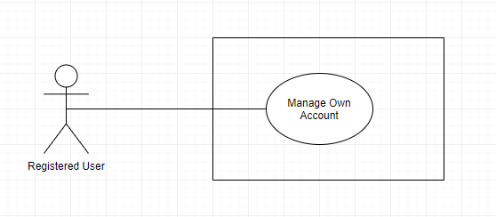

Figure 16: <Registered User> Manage User Profile

**Use Case Specification**

|  |  |  |  |
| --- | --- | --- | --- |
| **USE CASE - EMP_UC_04** | | | |
| **Use Case No.** | **EMP_UC_04** | **Use Case Version** | 1.0 |
| **Use Case Name** | Manage User Profile | | |
| **Author** |  | | |
| **Date** | 15/07/2019 | **Priority** | Normal |
| **Actor:**   * Registered User   **Summary:**   * This use case allows user to manage own account   **Goal:**   * User can edit their own account   **Triggers:**   * User clicks “User profile”. * User send manage account command to the system.   **Preconditions:**   * User must login into the system with role Registered User   **Post conditions:**   * Success: The profile successful updated. * Fail: Show error message   **Main Success Scenario:**   |  |  |  | | --- | --- | --- | | **Step** | **Actor Action** | **System Response** | | 1 | User goes to manage account view | The system requires input from user includes:   * Username: text, * First Name: text, * Last Name:text, * Email Address: text, * City: text, * Profile image: image, * Country: text, * Information: text, * Password: text, password | | 2 | User inputs information. |  | | 3 | User send edit profile command. | System shows message profile has been edited successfully.  [Exception 1]  [Exception 2] |   **Exception 1:**   |  |  |  | | --- | --- | --- | | **No** | **Cause** | **System Response** | | 1 | Edit profile fail. (Input contain special characters) | The system shows an error message “Input may not contain special characters” |   **Exception 2:**   |  |  |  | | --- | --- | --- | | **Step** | **Cause** | **System Response** | | 1 | When the connection to the server is lost | System shows message the "Please check your connection" when the internet is lost. |   **Relationships:** N/A.  **Business Rules:**   * After editing profile, Registered User must be verified again by staff * Registered User’s status change into “Not verified” | | | |

Table 21 <Registered User> Edit profile

##### <Registered User> View Report

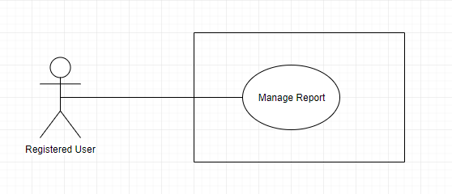

Figure 17: <Register User> View Report

**Use Case Specification**

|  |  |  |  |
| --- | --- | --- | --- |
| **USE CASE - EMP_UC_05** | | | |
| **Use Case No.** | **EMP_UC_05** | **Use Case Version** | 1.0 |
| **Use Case Name** | View report | | |
| **Author** |  | | |
| **Date** | 16/07/2019 | **Priority** | Normal |
| **Actor:**   * Registered User   **Summary:**   * This use case allows user to view report   **Goal:**   * User can view the report by week, month   **Triggers:**   * User send view report command. * User clicks on ”Dashboard”   **Preconditions:**   * User must login into the system with role Registered User.   **Post conditions:**   * Success: The report display on screen * Fail: The report cannot displayed on screen   **Main Success Scenario:**   |  |  |  | | --- | --- | --- | | **Step** | **Actor Action** | **System Response** | | 1 | User goes to dashboard | System display:  + The report by the latest campaign  + List contact by type  + List of group have been recently created  + List of contact have been recently added |   **Exception:**   |  |  |  | | --- | --- | --- | | **No** | **Actor Action** | **System Response** | | 1 | When the connection to the server is lost | System shows message the "Please check your connection" when the internet is lost. |   **Relationships:** N/A.  **Business Rules:**   * User can view the report of sent email, email pending by week, month * User can analyses the report | | | |

Table 22 <Registered User> Manage Report

##### <Registered User> Manage Contact

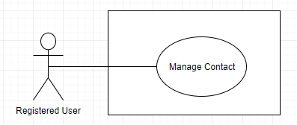

Figure 18: <Registered User> Manage Contact

**Use Case Specification**

|  |  |  |  |
| --- | --- | --- | --- |
| **USE CASE - EMP_UC_6** | | | |
| **Use Case No.** | **EMP_UC_6** | **Use Case Version** | 1.0 |
| **Use Case Name** | Manage contact | | |
| **Author** |  | | |
| **Date** | 16/07/2019 | **Priority** | Normal |
| **Actor:**   * Registered User   **Summary:**   * This use case allows registered user to manage contacts   **Goal:**   * User can view all the list of contact   **Triggers:**   * User click “View contact” to see the contact list   **Preconditions:**   * User must login into the system with role Registered User.   **Post conditions:**   * Success: List all contact. * Fail: Show error message   **Main Success Scenario:**   |  |  |  | | --- | --- | --- | | **Step** | **Actor Action** | **System Response** | | 1 | User sends command to view the contact list | * The system show list of all contact [Exception 1] |   **Exception 1:**   |  |  |  | | --- | --- | --- | | **Step** | **Cause** | **System Response** | | 1 | When the connection to the server is lost | System shows message the "Please check your connection" when the internet is lost. |   **Relationships:** N/A.  **Business Rules:**   * User can view can view all the contact related to him, created in the past or the present * Each transaction has one of the following statuses at a time:   + New subscriber: contact is newly created   + Subscriber: contact is added for a time * User can see the following information about each contact:   + Email   + First name   + Last name   + Phone number   + Address   + Date of birth | | | |

Table 23 <Registered User> Manage contact

##### <Registered User> Add Contacts

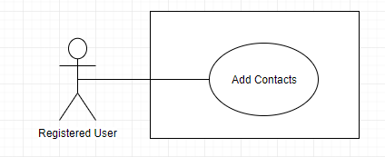

Figure 19: <Registered User> Add Contacts

**Use Case Specification**

|  |  |  |  |
| --- | --- | --- | --- |
| **USE CASE - EMP_UC_7** | | | |
| **Use Case No.** | **EMP_UC_7** | **Use Case Version** | 2.0 |
| **Use Case Name** | Add contacts | | |
| **Author** |  | | |
| **Date** | 14/06/2019 | **Priority** | Normal |
| **Actor:**   * Registered User   **Summary:**   * This use case allows Registered User to add a contact   **Goal:**   * User successfully add contacts   **Triggers:**   * User send add contact command to the system. * User clicks on “Manual add”   **Preconditions:**   * User must login into the system with role Registered User.   **Post conditions:**   * Success: New contact will be add to the default list * Fail: Show error messages   **Main Success Scenario:**   |  |  |  | | --- | --- | --- | | **Step** | **Actor Action** | **System Response** | | 1 | User goes to add contact screen | Display a table show all contacts with information:   * Email Address : @email.com * Status: * First Name * Last Name * Action | | 2 | User choose add contacts button | Display two option:   * Upload CSV file * Manual Add | | 3 | User chooses to upload CSV file | * Display two options: * Add contacts * Add contacts and include in an existing list   Choose CSV file to upload | | 4 | User chooses manual add | * Display two option: * Add contacts * Add contacts and include in an existing list | | 4.1 | User fill in contact info | * Display six field to fill * First name * Last name * Email * Phone number * Address * Date of birth | | 4.2 | User add more contact | * System add more six field   [Exception 1] | | 4.3 | User save contact | * System save new contact   [Exception 1]  [Exception 2] |   **Exception 1:**   |  |  |  | | --- | --- | --- | | **No** | **Cause** | **System Response** | | 1 | When the contact already in the list | System shows message the "This email is existed" when the contact already added to the list. |   **Exception 2:**   |  |  |  | | --- | --- | --- | | **No** | **Cause** | **System Response** | | 2 | When the connection to the server is lost | System shows message the "Please check your connection" when the internet is lost. |   **Relationships:** N/A.  **Business Rules:**   * Contact only contain related information * Contact can later update their information. * Contact is required for Email, First name, Last name. * A contact can have multiple group. * A contact contains the following information:   + Email   + First name   + Last name   + Phone number   + Address   + Date of birth | | | |

Table 24 <Registered User> Add Contacts

##### <Registered User> Delete Contacts

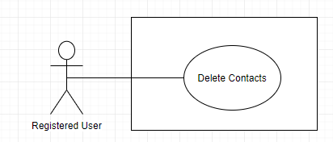

Figure 20: <Registered User> Delete contacts

**Use Case Specification**

|  |  |  |  |
| --- | --- | --- | --- |
| **USE CASE – EMP_UC_8** | | | |
| **Use Case No.** | **EMP_UC_8** | **Use Case Version** | 2.0 |
| **Use Case Name** | Delete contacts | | |
| **Author** |  | | |
| **Date** | 16/07/2019 | **Priority** | Normal |
| **Actor:**   * Authenticated Registered User   **Summary:**   * This use case allows User to delete contacts.   **Goal:**   * User successfully delete contacts in the system.   **Triggers:**   * User send delete command to the system.   **Preconditions:**   * User must login into the system with role Registered User. * Contact does not belong to any campaigns   **Post conditions:**   * Success: contacts is removed by user. * Fail: Show error message.   **Main Success Scenario:**   |  |  |  | | --- | --- | --- | | **Step** | **Actor Action** | **System Response** | | 1 | User goes to manage contacts screen. | Display a table show list of contacts. | | 2 | User send delete contacts command. | System start removing contacts.  [Exception 1]  [Exception 2]  System show message remove successful |   **Exception 1:**   |  |  |  | | --- | --- | --- | | **No** | **Cause** | **System Response** | | 1 | Removed fail. | Show message to notify User that remove failed. |   **Exception 2:**   |  |  |  | | --- | --- | --- | | **Step** | **Cause** | **System Response** | | 1 | When the connection to the server is lost | System shows message the "Please check your connection" when the internet is lost. |   **Relationships:** N/A  **Business Rules:**   * In case of success scenarios, contacts will be removed from the system. | | | |

Table 25 <Registered User> Delete contacts

##### <Registered User> Search Contact

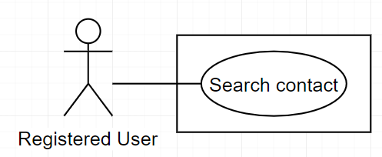

Figure 21: <Registered User> Search Contact

**Use Case Specification**

|  |  |  |  |
| --- | --- | --- | --- |
| **USE CASE – EMP_UC_14** | | | |
| **Use Case No.** | **EMP_UC_15** | **Use Case Version** | 1.1 |
| **Use Case Name** | Search Contact | | |
| **Author** |  | | |
| **Date** | 16/07/2019 | **Priority** | Normal |
| **Actor:**   * Registered User   **Summary:**   * This use case allows user to search contact by typing keyword   **Goal:**   * User search contact   **Triggers:**   * User send command to search contact   **Preconditions:**   * User must login to the system * The keyword must be included   **Post conditions:**   * Success: User can search contact * Fail: Show error message   **Main Success Scenario:**   |  |  |  | | --- | --- | --- | | **Step** | **Actor Action** | **System Response** | | 1 | User send command to search contact | System ask user to input keyword to search | | 2 | User input the keyword | System show the lists that match keyword |   **Alternative Scenario:**   |  |  |  | | --- | --- | --- | | **No** | **Actor Action** | **System Response** | | 1 | User input wrong keyword | System do not show anything |   **Exceptions:**   |  |  |  | | --- | --- | --- | | **No** | **Cause** | **System Response** | | 1 | No internet connection | System shows message the "Please check your connection" when the internet is lost. |   **Relationships:** N/A  **Business Rules:**   * User will get the search results list. | | | |

Table 31 : <Registered User> Search Group

##### <Registered User> Mange Templates

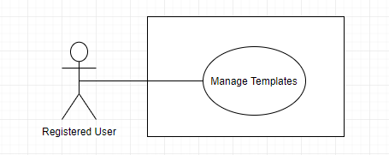

Figure 21: <Registered User> Manage Templates

**Use Case Specification**

|  |  |  |  |
| --- | --- | --- | --- |
| **USE CASE – EMP_UC_9** | | | |
| **Use Case No.** | **EMP_UC_9** | **Use Case Version** | 2.0 |
| **Use Case Name** | Manage templates | | |
| **Author** |  | | |
| **Date** | 16/07/2019 | **Priority** | High |
| **Actor:**   * Registered User   **Summary:**   * This use case allows registered user to manage templates   **Goal:**   * User can view all the list of templates   **Triggers:**   * User click to templates to see templates   **Preconditions:**   * User must login into the system with role Registered User.   **Post conditions:**   * Success: List all templates. * Fail: Show error message   **Main Success Scenario:**   |  |  |  | | --- | --- | --- | | **Step** | **Actor Action** | **System Response** | | 1 | User goes to Template | System show a list of Custom templates and Mindsending templates  [Exception 1] |   **Alternative Scenario: N/A**  **Exceptions:**   |  |  |  | | --- | --- | --- | | **No** | **Cause** | **System Response** | | 1 | No internet connection | System shows message the "Please check your connection" when the internet is lost. |   **Relationships:** N/A  **Business Rules:**   * User can view all the templates in the system: * Custom templates * Mindsending templates * User can preview template before choose * Action button to duplicate or edit template is allowed authority:   + User can only edit their own template | | | |

Table 26 <Registered User> Manage templates

##### <Registered User> Create New Template

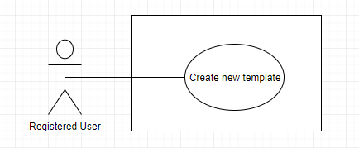

Figure 22: <Registered User> Create new template

**Use Case Specification**

|  |  |  |  |
| --- | --- | --- | --- |
| **USE CASE – EMP_UC_10** | | | |
| **Use Case No.** | **EMP_UC_10** | **Use Case Version** | 2.0 |
| **Use Case Name** | Create new template | | |
| **Author** |  | | |
| **Date** | 16/07/2019 | **Priority** | High |
| **Actor:**   * Registered user   **Summary:**   * This use case allows user to create new template   **Goal:**   * User can create new template   **Triggers:**   * User send command to create new template   **Preconditions:**   * User must login to the system with role Registered User   **Post conditions:**   * Success:   + New template will be added to the system * Fail: Show error message   **Main Success Scenario:**   |  |  |  | | --- | --- | --- | | **Step** | **Actor Action** | **System Response** | | 1 | User send the command to create new template | System suggest two option:   * Export HTML * Load HTML | | 2 | User save template | System show message “Đã thêm thành công”  [Exception ] |   **Exceptions:**   |  |  |  | | --- | --- | --- | | **No** | **Cause** | **System Response** | | 1 | No internet connection | System shows message the "Please check your connection" when the internet is lost. |   **Relationships:** N/A  **Business Rules:**   * User can review the template before save. * User can export HTML or load HTML on device to system | | | |

Table 27<Supplier> Accept pending hiring transaction

##### <Registered User> Edit Template

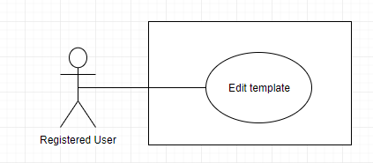

Figure 23: <Registered User> Edit template

**Use Case Specification**

|  |  |  |  |
| --- | --- | --- | --- |
| **USE CASE – EMP_UC_11** | | | |
| **Use Case No.** | **EMP_UC_11** | **Use Case Version** | 1.1 |
| **Use Case Name** | Edit template | | |
| **Author** |  | | |
| **Date** | 16/07/2019 | **Priority** | High |
| **Actor:**   * Registered User   **Summary:**   * This use case allows user to edit template   **Goal:**   * User edit template successfully   **Triggers:**   * User send command to edit template   **Preconditions:**   * User must login to the system   **Post conditions:**   * Success: Template edit successfully * Fail: Show error message   **Main Success Scenario:**   |  |  |  | | --- | --- | --- | | **Step** | **Actor Action** | **System Response** | | 1 | User view template before edit | System show template on screen | | 2 | User edit template |  | | 3 | User save edited template | System show message “ Template edited successfully” |   **Exceptions:**   |  |  |  | | --- | --- | --- | | **No** | **Cause** | **System Response** | | 1 | No internet connection | System shows message the "Please check your connection" when the internet is lost. |   **Relationships:** N/A  **Business Rules:**   * User can view the template before edit | | | |

Table 28 <Registered User> Edit template

##### <Registered User> Duplicate Template

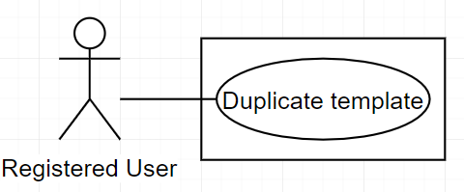

Figure 24: <Registered User> Duplicate Template

**Use Case Specification**

|  |  |  |  |
| --- | --- | --- | --- |
| **USE CASE – EMP_UC_12** | | | |
| **Use Case No.** | **EMP_UC_12** | **Use Case Version** | 1.0 |
| **Use Case Name** | Duplicate template | | |
| **Author** |  | | |
| **Date** | 16/07/2019 | **Priority** | Normal |
| **Actor:**   * Registered User   **Summary:**   * This use case allows user to duplicate template   **Goal:**   * User can duplicate template   **Triggers:**   * User click into duplicate button   **Preconditions:**   * User must login to the system   **Post conditions:**   * Success: Template is duplicated * Fail: Show error message   **Main Success Scenario:**   |  |  |  | | --- | --- | --- | | **Step** | **Actor Action** | **System Response** | | 1 | User sends command to duplicate template | System show duplicate pop-up | | 2 | User fill template name to duplicate |  | | 3 | User click save | System show message “Duplicate template successfully” |   **Exceptions:**   |  |  |  | | --- | --- | --- | | **No** | **Cause** | **System Response** | | 1 | No internet connection | System shows message the "Please check your connection" when the internet is lost. |   **Relationships:** N/A  **Business Rules:**   * By this action, user can view all contact lists. * The default behavior of duplication is to execute the action and automatically copy values from the current template into the new template with the new name | | | |

Table 29 <Registered User> Duplicate Template

##### <Registered User> Manage Group

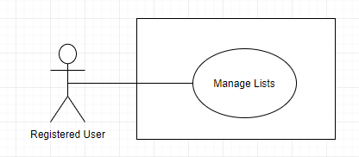

Figure 24: <Registered User> Manage Group

**Use Case Specification**

|  |  |  |  |
| --- | --- | --- | --- |
| **USE CASE – EMP_UC_12** | | | |
| **Use Case No.** | **EMP_UC_12** | **Use Case Version** | 1.0 |
| **Use Case Name** | Manage Group | | |
| **Author** |  | | |
| **Date** | 16/07/2019 | **Priority** | Normal |
| **Actor:**   * Registered User   **Summary:**   * This use case allows user to manage Group   **Goal:**   * User can manage Group   **Triggers:**   * User click into Group   **Preconditions:**   * User must login to the system   **Post conditions:**   * Success: Contact Group display on screen * Fail: Show error message   **Main Success Scenario:**   |  |  |  | | --- | --- | --- | | **Step** | **Actor Action** | **System Response** | | 1 | User goes to Group screen | System show a list of group  [Exception 1] |   **Exceptions:**   |  |  |  | | --- | --- | --- | | **No** | **Cause** | **System Response** | | 1 | No internet connection | System shows message the "Please check your connection" when the internet is lost. |   **Relationships:** N/A  **Business Rules:**   * User can view all the group related to him/her, created in the past or in the present * Each group included to one or many contact * User can see the following information about each campaign:   + Group name  + Description  + Contacts  + Action   * Action button to edit or delete group is allowed authority * User can choose to view group detail related to each group | | | |

Table 29 <Registered User> Manage lists

##### <Registered User> Create Group

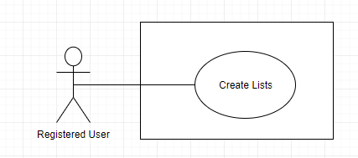

Figure 25: <Registered User> Create Group

**Use Case Specification**

|  |  |  |  |
| --- | --- | --- | --- |
| **USE CASE – EMP_UC_13** | | | |
| **Use Case No.** | **EMP_UC_13** | **Use Case Version** | 1.0 |
| **Use Case Name** | Create Group | | |
| **Author** |  | | |
| **Date** | 16/07/2018 | **Priority** | Normal |
| **Actor:**   * Registered user   **Summary:**   * This use case allows user to create Group   **Goal:**   * User create lists successfully   **Triggers:**   * User send command to create Group   **Preconditions:**   * User must login to the system   **Post conditions:**   * Success:   + This Group is added successfully * Fail: Show error message   **Main Success Scenario:**   |  |  |  | | --- | --- | --- | | **Step** | **Actor Action** | **System Response** | | 1 | User send the command to create Group | System show create Group pop-up | | 2 | User fill Group name and description to create |  | | 3 | User click create | System show message “Add group successfully” |   **Exceptions:**   |  |  |  | | --- | --- | --- | | **No** | **Cause** | **System Response** | | 1 | No internet connection | System shows message the "Please check your connection" when the internet is lost. |   **Relationships:** N/A  **Business Rules:**   * Group only contain related information * Group can later update their information. * Contact is required for Name and description. * A group can have multiple contact. * A group contains the following information:   + Name   + Description   + Contacts   + Action | | | |

Table 30: <Supplier> Confirm equipment returned

##### <Registered User> Search Group

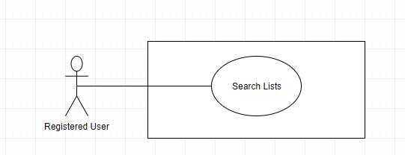

Figure 26: <Registered User> Search Group

**Use Case Specification**

|  |  |  |  |
| --- | --- | --- | --- |
| **USE CASE – EMP_UC_14** | | | |
| **Use Case No.** | **EMP_UC_14** | **Use Case Version** | 1.1 |
| **Use Case Name** | Search Group | | |
| **Author** |  | | |
| **Date** | 16/07/2019 | **Priority** | Normal |
| **Actor:**   * Registered User   **Summary:**   * This use case allows user to search lists by typing keyword   **Goal:**   * User search Group   **Triggers:**   * User send command to search Group   **Preconditions:**   * User must login to the system * The keyword must be included   **Post conditions:**   * Success: User can search Group * Fail: Show error message   **Main Success Scenario:**   |  |  |  | | --- | --- | --- | | **Step** | **Actor Action** | **System Response** | | 1 | User send command to search Group | System ask user to input keyword to search | | 2 | User input the keyword | System show the lists that match keyword |   **Alternative Scenario:**   |  |  |  | | --- | --- | --- | | **No** | **Actor Action** | **System Response** | | 1 | User input wrong keyword | System donot show anything |   **Exceptions:**   |  |  |  | | --- | --- | --- | | **No** | **Cause** | **System Response** | | 1 | No internet connection | System shows message the "Please check your connection" when the internet is lost. |   **Relationships:** N/A  **Business Rules:**   * User will get the search results list. | | | |

Table 31 : <Registered User> Search Group

##### <Registered User> Delete Group

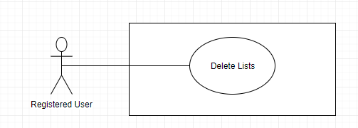

Figure 27: <Registered User> Delete Group

**Use Case Specification**

|  |  |  |  |
| --- | --- | --- | --- |
| **USE CASE – EMP_UC_15** | | | |
| **Use Case No.** | **EMP_UC_15** | **Use Case Version** | 1.0 |
| **Use Case Name** | Delete Group | | |
| **Author** |  | | |
| **Date** | 16/07/2019 | **Priority** | High |
| **Actor:**   * Registered user   **Summary:**   * This use case allows user to delete Group   **Goal:**   * User delete Group successfully   **Triggers:**   * User send command to delete Group   **Preconditions:**   * User must login to the system * Group does not belong to any campaigns   **Post conditions:**   * Success:   + The request status changed to “Accepted” * Fail: Show error message   **Main Success Scenario:**   |  |  |  | | --- | --- | --- | | **Step** | **Actor Action** | **System Response** | | 1 | User send the command to delete Group | System ask user to confirm the action | | 2 | User choose to confirm the accept action [Alternative 1] | System show message that the request is approved  [Exception 1] |   **Exceptions:**   |  |  |  | | --- | --- | --- | | **No** | **Cause** | **System Response** | | 1 | No internet connection | System shows message the "Please check your connection" when the internet is lost. |   **Relationships:** N/A  **Business Rules:**   * In case of success scenarios, group will be removed from the system. | | | |

Table 32 <Registered User> Delete Group

##### <Registered User> Manage Appointment

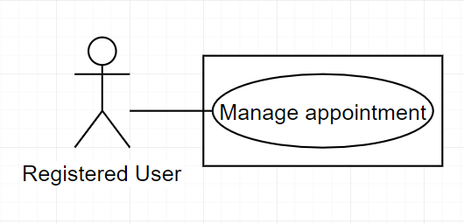

Figure 28: <Registered User> Manage Appointment

**Use Case Specification**

|  |  |  |  |
| --- | --- | --- | --- |
| **USE CASE – EMP_UC_16** | | | |
| **Use Case No.** | **EMP_UC_16** | **Use Case Version** | 1.0 |
| **Use Case Name** | Manage Appointment | | |
| **Author** |  | | |
| **Date** | 17/06/2019 | **Priority** | High |
| **Actor:**   * Registered User   **Summary:**   * This use case allows user to manage appointment   **Goal:**   * User can manage all appointment   **Triggers:**   * Supplier send command to show all appointment   **Preconditions:**   * User must login to the system   **Post conditions:**   * Success: System will show all appointment on screen * Fail: Show error message   **Main Success Scenario:**   |  |  |  | | --- | --- | --- | | **Step** | **Actor Action** | **System Response** | | 1 | User send the command to show all appointment | System show a list of appointment  [Exception 1] |   **Exceptions:**   |  |  |  | | --- | --- | --- | | **No** | **Cause** | **System Response** | | 1 | No internet connection | System shows message the "Please check your connection" when the internet is lost. |   **Relationships:** N/A  **Business Rules:**   * User can view all the appointment related to him/her, created in the past or in the present * Each appointment include one or many group * User can see the following information about each appointment:   + Name  + Start on  + Invitations sent  + Invitations sent  + Registrants  + Action   * User can choose to view appointment detail related to each appointment | | | |

Table 33 <Registered User> Manage appointment

##### <Registered User> Manage Embed Form

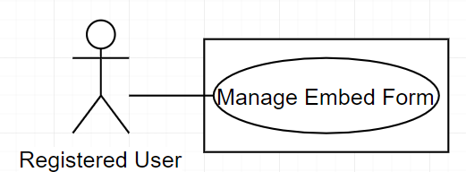

Figure 28: <Registered User> Manage Embed Form

**Use Case Specification**

|  |  |  |  |
| --- | --- | --- | --- |
| **USE CASE – EMP_UC_16** | | | |
| **Use Case No.** | **EMP_UC_16** | **Use Case Version** | 1.0 |
| **Use Case Name** | Manage Embed Form | | |
| **Author** |  | | |
| **Date** | 17/06/2019 | **Priority** | High |
| **Actor:**   * Registered User   **Summary:**   * This use case allows user to manage Embed Form   **Goal:**   * User can manage all Embed Form   **Triggers:**   * Supplier send command to show all Embed Form   **Preconditions:**   * User must login to the system   **Post conditions:**   * Success: System will show all Embed Form on screen * Fail: Show error message   **Main Success Scenario:**   |  |  |  | | --- | --- | --- | | **Step** | **Actor Action** | **System Response** | | 1 | User send the command to show all campaigns | System show a list of Embed Form  [Exception 1] |   **Exceptions:**   |  |  |  | | --- | --- | --- | | **No** | **Cause** | **System Response** | | 1 | No internet connection | System shows message the "Please check your connection" when the internet is lost. |   **Relationships:** N/A  **Business Rules:**   * User can view all the Embed Form related to him/her, created in the past or in the present * Each Embed Form include one group * User can see the following information about each Embed Form:   + Form name  + Create on  + Group contact  + Action   * User can choose to view Embed Form detail related to each Embed Form * User can choose to copy code from Embed Form that | | | |

Table 33 <Registered User> Manage Embed Form

##### <Registered User> Manage Campaigns

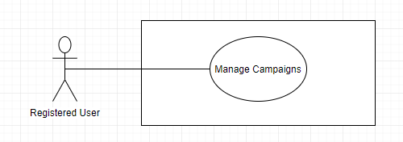

Figure 28: <Registered User> Manage Campaigns

**Use Case Specification**

|  |  |  |  |
| --- | --- | --- | --- |
| **USE CASE – EMP_UC_16** | | | |
| **Use Case No.** | **EMP_UC_16** | **Use Case Version** | 1.0 |
| **Use Case Name** | Manage Campaigns | | |
| **Author** |  | | |
| **Date** | 17/06/2019 | **Priority** | High |
| **Actor:**   * Registered User   **Summary:**   * This use case allows user to manage campaigns   **Goal:**   * User can manage all campaigns   **Triggers:**   * Supplier send command to show all campaigns   **Preconditions:**   * User must login to the system   **Post conditions:**   * Success: System will show all campaigns on screen * Fail: Show error message   **Main Success Scenario:**   |  |  |  | | --- | --- | --- | | **Step** | **Actor Action** | **System Response** | | 1 | User send the command to show all campaigns | System show a list of campaign  [Exception 1] |   **Exceptions:**   |  |  |  | | --- | --- | --- | | **No** | **Cause** | **System Response** | | 1 | No internet connection | System shows message the "Please check your connection" when the internet is lost. |   **Relationships:** N/A  **Business Rules:**   * User can view all the regular campaign related to him/her, created in the past or in the present * Each campaign include one or many group * Each campaign has one of the following statuses at a time:   + Draft: mail is not sent  + Sending: mail is sending  + Done: mail is sent   * User can see the following information about each campaign:   + Status  + Campaign name  + Delivery  + Opens  + Clicks  + Action   * Action button to change campaign status is allowed authority * User can choose to view campaign detail related to each campaign * User can choose to duplicate campaign | | | |

Table 33 <Registered User> Manage Campaigns

##### <Registered User> Create Regular Campaigns

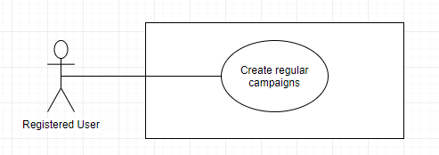

Figure 29: <Registered User> Create regular campaigns

**Use Case Specification**

|  |  |  |  |
| --- | --- | --- | --- |
| **USE CASE – EMP_UC_17** | | | |
| **Use Case No.** | **EMP_UC_17** | **Use Case Version** | 1.1 |
| **Use Case Name** | Create regular campaigns | | |
| **Author** |  | | |
| **Date** | 16/07/2019 | **Priority** | High |
| **Actor:**   * Registered User   **Summary:**   * This use case allows user to create regular campaigns   **Goal:**   * User can create regular campaigns   **Triggers:**   * User send command to create regular campaigns   **Preconditions:**   * User must login to the system   **Post conditions:**   * Success: New campaigns is added * Fail: Show error message   **Main Success Scenario:**   |  |  |  | | --- | --- | --- | | **Step** | **Actor Action** | **System Response** | | 1 | User goes to regular campaigns | System show all campaigns and campaign statistics   * Status * Campaign Name * Clicks * Opens * Unsubscribe | | 2 | User click to create campaign | System show message to confirm create campaigns | | 3 | User input campaigns information | System show campaigns information to input:   * To * From * Subject * Content | | 4 | User confirm the action  [Alternative 1] | System display successful message  [Exception 1] |   **Alternative Scenario:**   |  |  |  | | --- | --- | --- | | **No** | **Actor Action** | **System Response** | | 1 | User input |  |   **Exceptions:**   |  |  |  | | --- | --- | --- | | **No** | **Cause** | **System Response** | | 1 | No internet connection | System shows message the "Please check your connection" when the internet is lost. | | 2 | User input invalidate information. | System show error message for the input mistake |   **Relationships:** N/A  **Business Rules:**   * Campaign only contain related information * Campaign can later update their information. * Campaign is required for Group contact, Sender name, Email Address, subject and content. * A campaign can have multiple group. * A campaign contains the following information:   + status   + campaign name   + delivery   + open   + click   + Action | | | |

Table 34 <Registered User> Create Regular Campaigns

##### <Registered User> Edit Regular Campaigns

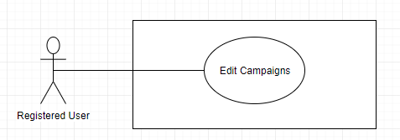

Figure 31: <Registered User> Edit Regular Campaigns

**Use Case Specification**

|  |  |  |  |
| --- | --- | --- | --- |
| **USE CASE – EMP_UC_19** | | | |
| **Use Case No.** | **EMP_UC_19** | **Use Case Version** | 1.0 |
| **Use Case Name** | Edit Campaigns | | |
| **Author** |  | | |
| **Date** | 18/07/2019 | **Priority** | Normal |
| **Actor:**   * Registered User   **Summary:**   * This use case allows user to edit campaigns   **Goal:**   * User can edit campaigns   **Triggers:**   * User send command to edit campaigns   **Preconditions:**   * User must login to the system * Campaign status is Draft   **Post conditions:**   * Success: The campaigns is edited * Fail: Show error message   **Main Success Scenario:**   |  |  |  | | --- | --- | --- | | **Step** | **Actor Action** | **System Response** | | 1 | User go to editing campaigns | System requires information about campaigns to edit, which contains:   * Group * To * From * Subject * Content | | 2 | User input information |  | | 3 | User send command to save new campaign | System validate information, display request for confirmation | | 4 | User confirm the action  [Alternative 1] | System display successful message  [Exception 1] |   **Alternative Scenario:**   |  |  |  | | --- | --- | --- | | **No** | **Actor Action** | **System Response** | | 1 | User choose not to confirm the action | System hides the message and go back to inputting view |   **Exceptions:**   |  |  |  | | --- | --- | --- | | **No** | **Cause** | **System Response** | | 1 | No internet connection | System shows message the "Please check your connection" when the internet is lost. | | 2 | User input invalidate information. | System show error message for the input mistake |   **Relationships:** N/A  **Business Rules:**   * User can view the campaign before edit * User cannot edit campaign with “Done” status * Further information can be found in Use Case <EMP_UC_19> (Create regular campaign) | | | |

Table 36 : <Registered User> Edit Campaigns

##### <Registered User> Create Workflow

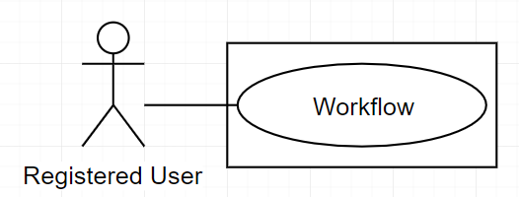

Figure 30: <Registered User> Create Workflow

**Use Case Specification**

|  |  |  |  |
| --- | --- | --- | --- |
| **USE CASE – EMP_UC_18** | | | |
| **Use Case No.** | **EMP_UC_18** | **Use Case Version** | 1.1 |
| **Use Case Name** | Create Workflow | | |
| **Author** |  | | |
| **Date** | 16/07/2019 | **Priority** | Normal |
| **Actor:**   * Registered User   **Summary:**   * This use case allows user to create Workflow   **Goal:**   * User can create Workflow   **Triggers:**   * User send command to create Workflow   **Preconditions:**   * User must login to the system   **Post conditions:**   * Success: The Workflow is created * Fail: Show error message   **Main Success Scenario:**   |  |  |  | | --- | --- | --- | | **Step** | **Actor Action** | **System Response** | | 1 | User send the command to create automation campaigns | System show information to input | | 2 | User choose to confirm the approve action  [Alternative] | System show message that the campaign is created |   **Alternative Scenario:**   |  |  |  | | --- | --- | --- | | **No** | **Actor Action** | **System Response** | | 1 | User choose not to confirm the action | System hides the message and does nothing |   **Exceptions:**   |  |  |  | | --- | --- | --- | | **No** | **Cause** | **System Response** | | 1 | No internet connection | System shows message the "Please check your connection" when the internet is lost. | | 2 | The condition of the equipment is not valid to delete | System shows message about the invalid condition |   **Relationships:** N/A  **Business Rules:** | | | |

Table 35 <Registered User> Create automation campaigns

#### <Admin guest> Overview Use Case

Figure 109: <Admin guest>Overview use case

##### <Admin guest> Login to web admin

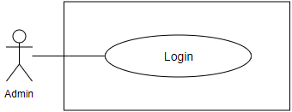

Figure 110: <Admin guest>Login to web admin

**Use Case Specification**

|  |  |  |  |
| --- | --- | --- | --- |
| **USE CASE – EMP_UC_102** | | | |
| **Use Case No.** | **EMP_UC_102** | **Use Case Version** | 1.1 |
| **Use Case Name** | Login to web admin | | |
| **Author** |  | | |
| **Date** |  | **Priority** | Normal |
| **Actor:**   * Admin guest   **Summary:**   * This use case allows guest to log in the system.   **Goal:**   * Guest can log in the system with specific role.   **Triggers:**   * Guest sends login command.   **Preconditions:** N/A  **Post conditions:**   * Success: Guest is exactly authorized with specific role in the system. * Fail: System shows error messages.   **Main Success Scenario:**   |  |  |  | | --- | --- | --- | | **Step** | **Actor Action** | **System Response** | | 1 | Guest go to login screen. | Login screen is shown with following labels and fields:   * Username: text input, required. * Password: text input, required. | | 2 | Guest inputs information. |  | | 3 | Guest sends command to login to system. | Guest logins system with his specific role. [Alternative 1] [Exception 1] |   **Alternative Scenario:**   |  |  |  | | --- | --- | --- | | **No** | **Actor Action** | **System Response** | | 1 | Guest enter wrong identity information. | System shows error message “Wrong username or password. Please try again.” |   **Exceptions:**   |  |  |  | | --- | --- | --- | | **No** | **Cause** | **System Response** | | 1 | Login failed. | Show message to notify admin that login failed. |   **Relationships:** N/A  **Business Rules:**   * Password is encrypted before being sent to server. | | | |

##### <Admin guest> Forgot your password

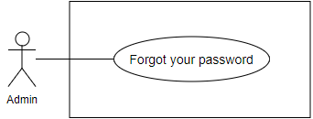

Figure 111: <Admin guest>Forgot your password

**Use Case Specification**

|  |  |  |  |
| --- | --- | --- | --- |
| **USE CASE – EMP_UC_103** | | | |
| **Use Case No.** | **EMP_UC_103** | **Use Case Version** | 1.1 |
| **Use Case Name** |  | | |
| **Author** |  | | |
| **Date** |  | **Priority** | Normal |
| **Actor:**   * Admin guest   **Summary:**   * This use case allows guest to reset password by email.   **Goal:**   * Guest can reset password by email.   **Triggers:**   * Guest sends reset password command.   **Preconditions:** N/A  **Post conditions:**   * Success: A staff password successful update in database and send to staff’s email. * Fail: A staff password cannot be updated.   **Main Success Scenario:**   |  |  |  | | --- | --- | --- | | **Step** | **Actor Action** | **System Response** | | 1 | Guest go to forgot your password screen. | Forgot your password screen is shown with following labels and fields:   * Email: text input, required. | | 2 | Guest inputs information. |  | | 3 | Guest sends command to reset password to system. | Update staff password in the system.  [Alternative 1]  [Exception 1]  System shows message reset password has been updated successfully |   **Alternative Scenario:**   |  |  |  | | --- | --- | --- | | **No** | **Actor Action** | **System Response** | | 1 | Guest enter wrong identity information. | System shows error message” Wrong email.” |   **Exceptions:**   |  |  |  | | --- | --- | --- | | **No** | **Cause** | **System Response** | | 1 | Reset password failed. | Show message to notify admin that reset password failed. |   **Relationships:** N/A  **Business Rules:**   * Password is encrypted before being sent to server. * Email have been registered before. | | | |

## Software System Attribute

### Usability

Website’s UI is fit for each browser on each device

* Font style: Arial, Sans-serif
* Font size: 12px -26px
* Color: green, black, red, white, blue, Light Slate Grey, Fuego, Honeysuckle…
* Background: White, Catalina Blue, Whisper…

### Reliability

* The information storing on the database is permanent.

### Availability

* The system must be available at any time 24/7.

### Security

* Only Manager has fully access to the system
* Input data is validated before saving to database.

### Maintainability

* The system is divided into separated modules for easy maintain.

### Portability

* Web application can be run on Chrome browser version 42 or later

### Performance

* System has successfully test with basic standard

## Conceptual Diagram

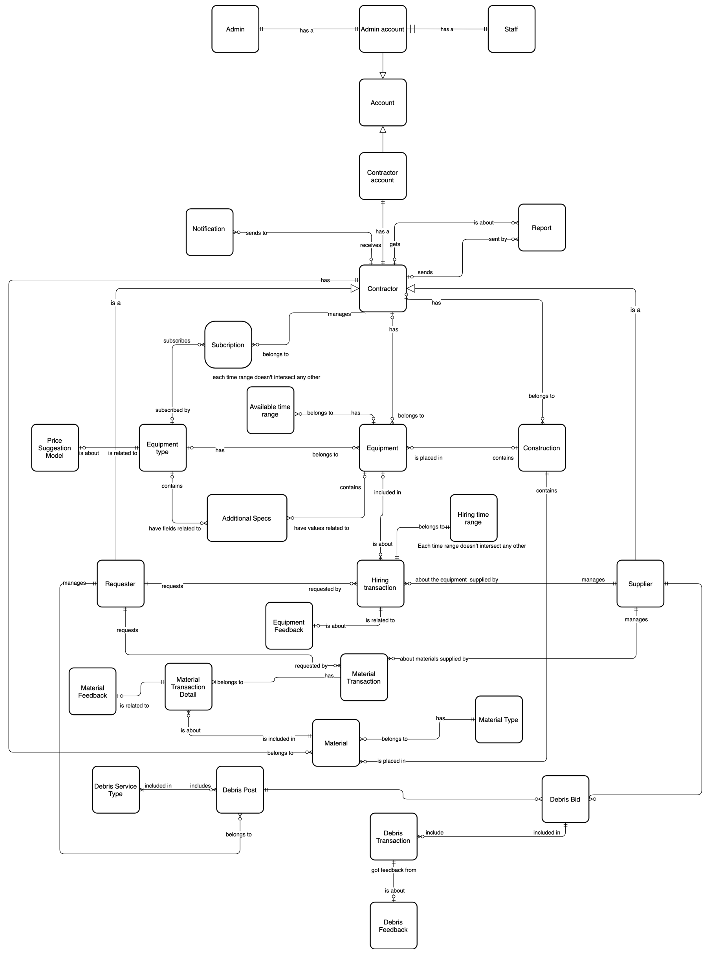

Figure 4 Conceptual Diagram

**Data Dictionary**

|  |  |
| --- | --- |
| **ENTITY DATA DICTIONARY: DESCRIBE ALL CONTENT OF ALL ENTITIES** | |
| **Entity Name** | **Description** |
| Additional Specs | Contain all additional specs information |
| Account | Contain account information |
| Admin account | Contain admin account information |
| Admin | Contain the admin information |
| Available time range | Contain available time range information of an equipment |
| Construction | Contain construction information |
| Registered User | Contain Registered User profile information |
| Registered User account | Contain Registered User account information |
| Equipment | Contain equipment information |
| Equipment type | Contain equipment type information |
| Report | Contain information of reported behavior |
| Hiring transaction | Contain hiring transaction information |
| Hiring time range | Contain hiring time range information |
| Notification | Describe a handler which will manage notifications of the system |
| Subscription | Contain subscription information |
| Material | Contain material information |
| Material transaction | Contain material transaction information |
| Material type | Contain material type information |
| Debris bid | Contain bid information for a debris post |
| Debris feedback | Contain feedback information for a finished debris transaction |
| Debris post | Contain post information for a debris service |
| Debris service type | Contain debris service type information |
| Debris transaction | Contain debris transaction information |
| Material transaction detail | Contain material transaction detail information |
| Material feedback | Contain feedback information of a finished material transaction |
| Equipment feedback | Contain feedback information for a finished hiring transaction |
| Supplier | Contain supplier information |
| Staff | Contain the staff information |
| Requester | Contain requester information |
| Price suggestion model | Contain information of the price suggestion model training result |

Table 100 Conceptual Diagram Dictionary

# Software Design Description

## Design Overview

This document describes the technical and user interface design of EMP system. It includes the architectural design, the detailed design of common functions and business functions and the design of database model.

The architectural design describes the overall architecture of the system and the architecture of each main component and subsystem.

The detailed design describes static and dynamic structure for each component and functions. It includes class diagram EMP, class explanations and sequence diagram EMP for each use cases.

 The database design describes the relationships between entities and details of each entity.

Document overview:

* Section 2: gives an overall description of the system architecture design.
* Section 3: gives component diagram EMP that describe the connection and integration of the system.
* Section 4: gives the detail design description which includes class diagram, class explanation, and sequence diagram to details the application functions.
* Section 5: describe screens design.
* Section 6: describe a fully attributed ERD.
* Section 7: describe algorithm EMP.

## System Architecture Design

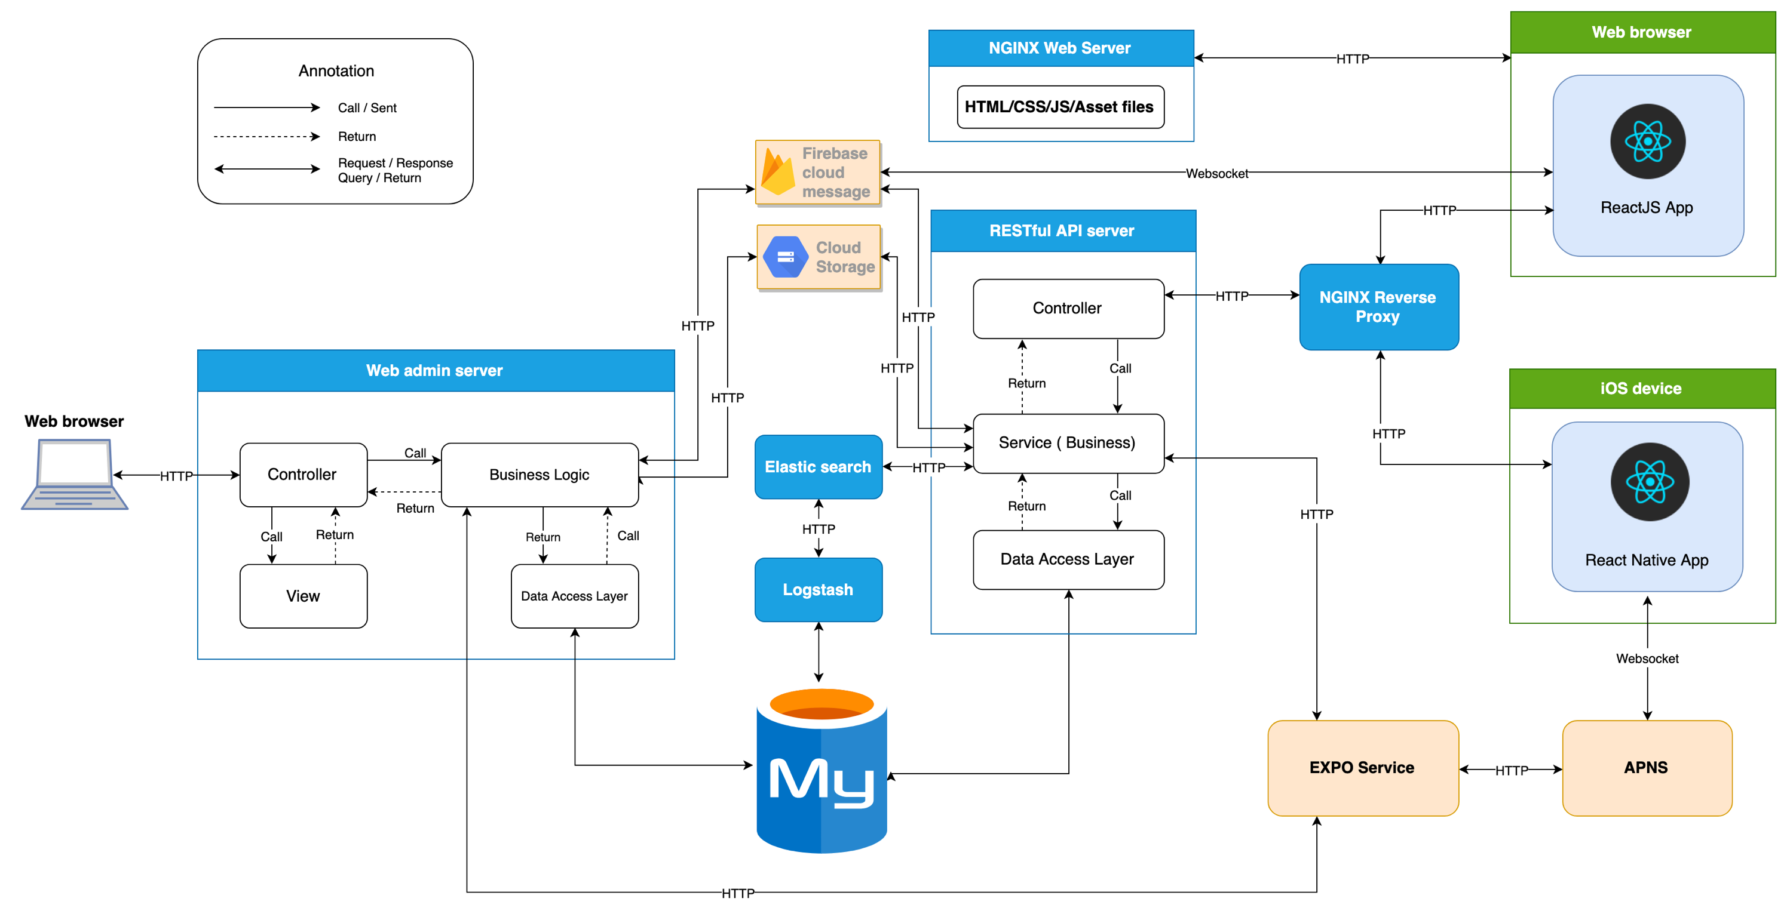

Figure 5 System Architecture diagram

### Admin web application:

In Admin Web Application, the system is developed under MVC architecture style. We choose this architecture for Admin Web Application because the following advantages:

* Quickly to develop and maintain, because the lack of human resource of our team
* Have enough flexibility and maintainability, comprehension, convention because MVC model is a classical model with variety resources and eco system.
* Save memory leaks with small amount of Javascript because of server-side rendering
* No need heavy loading in client, save computing resources for devices in offices
* Preferable for simple applications

### Registered User web system:

In Registered User web application, we choose to develop the system in Single Page Application approach because of the following advantages:

* Provide rich user interface with many features, preferable for C2C or B2C products
* Better UX/UI for end users for quick data loading and background fetching
* ReactJS is easy to master
* It is a light-weighted framework comparing to other popular ones today

In Registered User mobile application, we choose to develop the system with React Native because of the following advantages:

* Mobile app can be built with the help of Web technology which enables any web developer to easily enhance his/her skills and create React apps.
* Saves time and cost to build mobile apps on multiple platform EMP.
* A React Native app ensures speed and agility for the mobile apps with responsiveness and a great native app based user experience.

## Component Diagram

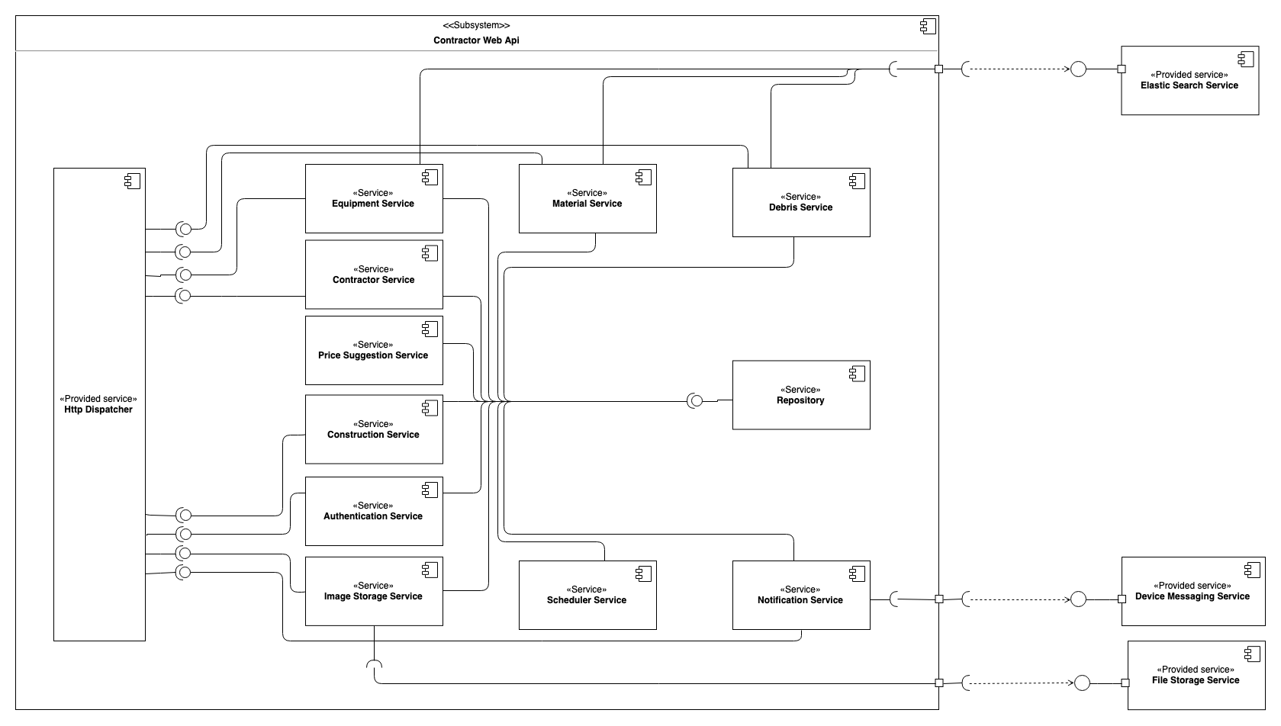

Figure 6 Component Diagram - Registered User Web Api

|  |  |
| --- | --- |
| **Component dictionary** | |
| **Component name** | **Description** |
| Equipment Service | A service responsible for managing information related to equipment, hiring transaction, hiring transaction feedbacks. |
| Material Service | A service responsible for managing information related to materials, material transactions, material transaction feedbacks. |
| Debris Service | A service responsible for managing information related to debris, debris post, debris bids, debris transactions, debris transaction feedbacks. |
| Registered User Service | A service responsible for managing information related to Registered Users. |
| Construction Service | A service responsible for managing information related to constructions. |
| Authentication Service | A service responsible for authentication and authorization. |
| Image Storage Service | A service responsible for uploading images, including equipment images, material images, debris images, profile images. |
| Scheduler Service | A service responsible for time-related tasks. |
| Notification Service | A service responsible for managing notification |
| Repository | A service responsible for data management. |
| Elastic Search Service | A provided service of Elastic search, responsible for low-latency performance information gathering and managing searchable resource |
| Device Messaging Service | An external service responsible for send notifications to actual devices. This service can be realized by Firebase Cloud Messaging service and Expo Messaging service. |
| File Storage Service | An external service responsible for raw resource storage. This service can be realized by Google Cloud Storage service, Imgur Storage service, etc. |
| Price Suggestion Service | A service responsible for model training, data collecting data, data processing, model applying for price suggestion. |

Figure 7 Component Data Dictionary

## Detailed Description

### Class Diagram

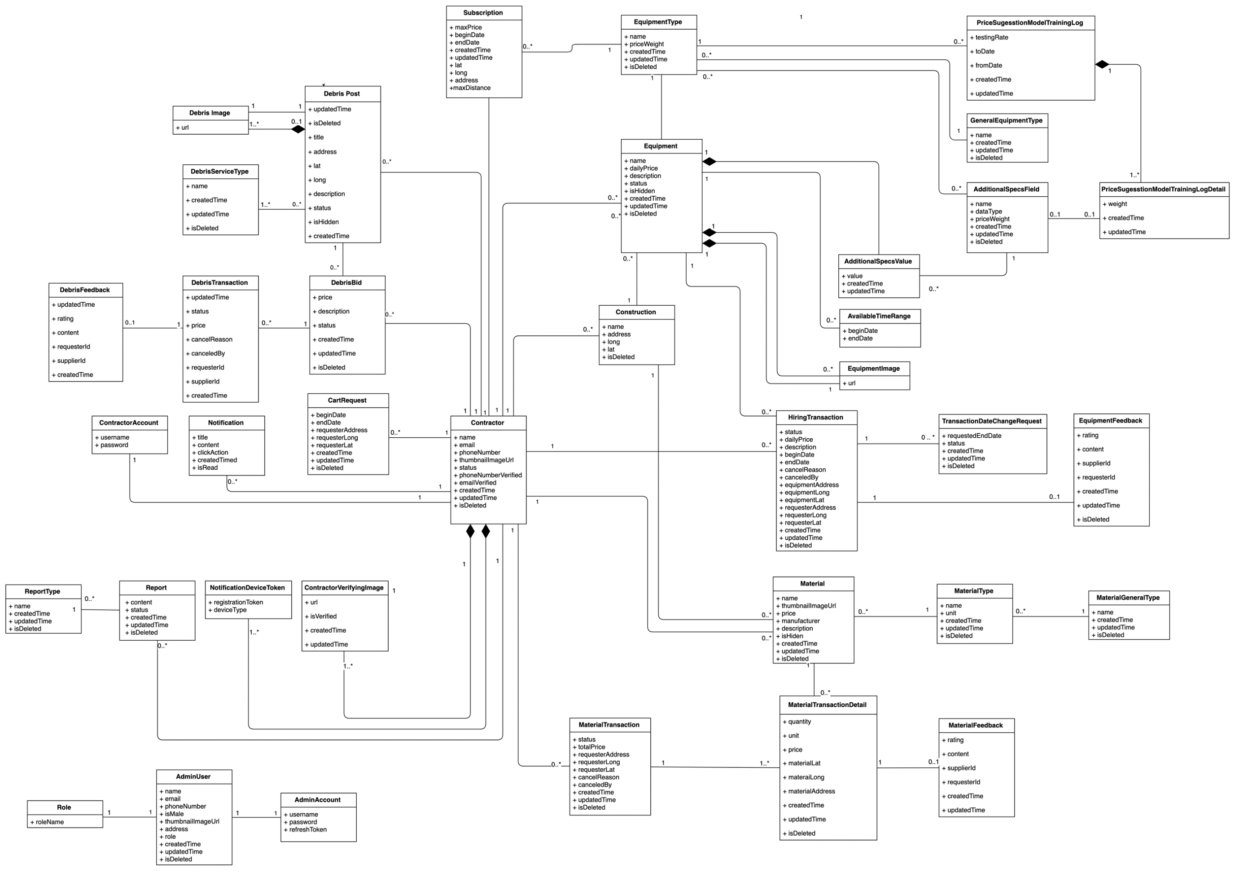

Figure 8 Class Diagram

### Class Diagram Explanation

### Interaction Diagram

#### Registered User web application

## Interface

### Component Interface

### User Interface Design

#### Registered User web application

##### Login

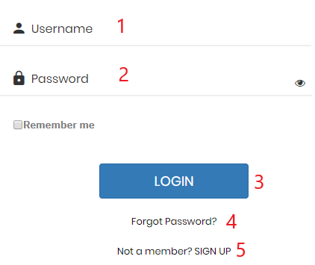

Figure 23 Login

**Fields**

|  |  |  |  |  |  |  |
| --- | --- | --- | --- | --- | --- | --- |
| **No** | **Field Name** | **Description** | **Read only** | **Mandatory** | **Control Type** | **Data Type** |
| 1 | Username | Username to login | No | Yes | TextBox | String |
| 2 | Password | Password to login | No | Yes | TexBox | String |

Table 101 <Fields> Login

**Buttons/Hyperlinks:**

|  |  |  |  |  |
| --- | --- | --- | --- | --- |
| **No** | **Function** | **Description** | **Validation** | **Outcome** |
| 3 | Login | Login into the system | Required | User logged in into the system |
| 4 | Forgot Password | User forget and want to take back password | N/A | User is redirected to a page for filling in new password |
| 5 | [Not a member? SIGN UP](http://localhost:3000/register) | User sign up new account | N/A | User is redirected into the sign up page |

Table 102 <Buttons/Hyperlinks> Login

##### Sign Up

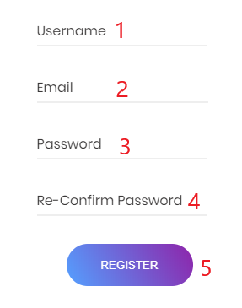

**Fields**

|  |  |  |  |  |  |  |
| --- | --- | --- | --- | --- | --- | --- |
| **No** | **Field Name** | **Description** | **Read only** | **Mandatory** | **Control Type** | **Data Type** |
| 1 | Username | Username to sign up | No | Yes | TextBox | String |
| 2 | Email | Email to sign up | No | Yes | Textbox | String |
| 3 | Password | Password to sign up | No | Yes | TexBox | String |
| 4 | Re-Confirm password | Confirm enterred password | No | Yes | TextBox | String |

Table 103 <Fields> Sign Up

**Buttons/Hyperlinks:**

|  |  |  |  |  |
| --- | --- | --- | --- | --- |
| **No** | **Function** | **Description** | **Validation** | **Outcome** |
| 5 | Register | User sign up new account | Required | User signed up new account successfully |

Table 104 <Buttons/Hyperlinks> Sign Up

##### Main menu

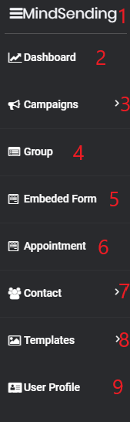

**Buttons/Hyperlinks:**

|  |  |  |  |  |
| --- | --- | --- | --- | --- |
| **No** | **Function** | **Description** | **Validation** | **Outcome** |
| 1 | MindSending | Home | User must had been authorized | Redirect to home page |
| 2 | Dashboard | Report page | User must had been authorized | Redirect to report page |
| 3 | Campaign | Campaign page | User must had been authorized | Redirect to campaign page |
| 4 | Group | Group contact page | User must had been authorized | Redirect to group contact page |
| 5 | Embed Form | Embed form page | User must had been authorized | Redirect to embed form page |
| 6 | Appointment | Appointment page | User must had been authorized | Redirect to appointment page |
| 7 | Contact | Contact page | User must had been authorized | Redirect to contact page |
| 8 | Template | Template page | User must had been authorized | Redirect to template page |
| 9 | User profile | User profile page | User must had been authorized | Redirect to user profile page |

Table 105 <Buttons/Hyperlinks> Main menu

##### Campaign menu

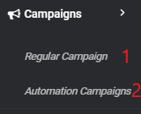

**Buttons/Hyperlinks:**

|  |  |  |  |  |
| --- | --- | --- | --- | --- |
| **No** | **Function** | **Description** | **Validation** | **Outcome** |
| 1 | Regular Campaign | Regular Campaign page | User must had been authorized | Redirect to Regular Campaign page |
| 2 | Automation Campaigns | Automation Campaigns page | User must had been authorized | Redirect to Automation Campaigns page |

Table 106 <Buttons/Hyperlinks> Equipment menu

##### Group

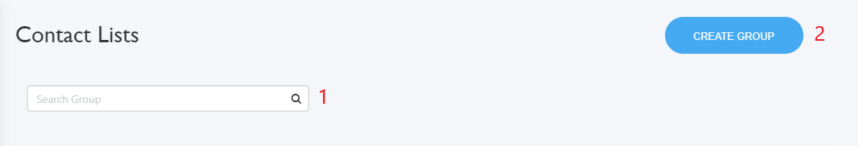

**Buttons/Hyperlinks:**

|  |  |  |  |  |
| --- | --- | --- | --- | --- |
| **No** | **Function** | **Description** | **Validation** | **Outcome** |
| 1 | Find materials | Search group by name | N/A | Group with corresponding result |
| 2 | Create Group | Button for creating group | User must had been authorized | Redirect to create group pop-up |

Table 107 <Buttons/Hyperlinks> Material menu

##### Embed form

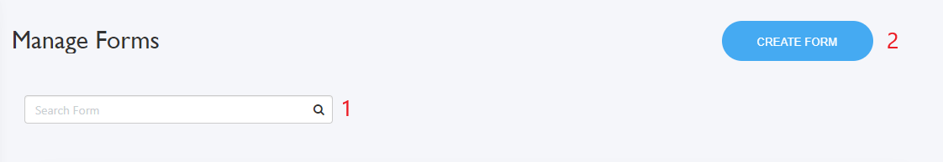

**Buttons/Hyperlinks:**

|  |  |  |  |  |
| --- | --- | --- | --- | --- |
| **No** | **Function** | **Description** | **Validation** | **Outcome** |
| 1 | Search Form | Search form by name | N/A | Form with corresponding result |
| 2 | Create Form | Button for creating form | User must had been authorized | Redirect to create form page |

Table 108 <Buttons/Hyperlinks> Debris menu

##### Appointment

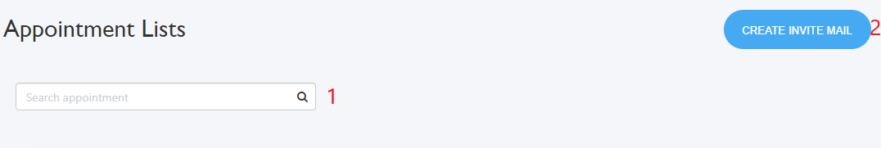

**Buttons/Hyperlinks:**

|  |  |  |  |  |
| --- | --- | --- | --- | --- |
| **No** | **Function** | **Description** | **Validation** | **Outcome** |
| 1 | Search Appointment | Search appointment by name | N/A | appointment with corresponding result |
| 2 | Create Invite Mail | Button for creating appointment | User must had been authorized | Redirect to create appointment page |

Table 109 <Buttons/Hyperlinks> User menu

##### Contact

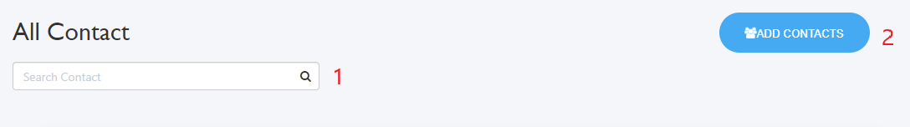

**Buttons/Hyperlinks:**

|  |  |  |  |  |
| --- | --- | --- | --- | --- |
| **No** | **Function** | **Description** | **Validation** | **Outcome** |
| 1 | Search Contact | Search contact by name | N/A | Contact with corresponding result |
| 2 | Create Contacts | Button for creating Contact | User must had been authorized | Redirect to create Contacts page |

Table 110 <Fields> Equipment search

##### Templates

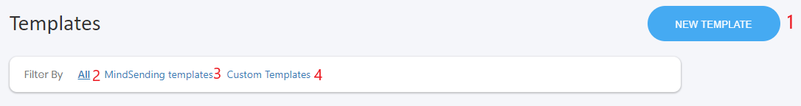

**Buttons/Hyperlinks:**

|  |  |  |  |  |
| --- | --- | --- | --- | --- |
| **No** | **Function** | **Description** | **Validation** | **Outcome** |
| 1 | New Template | Button for creating template | User must had been authorized | Redirect to create template page |
| 2 | All | List all template | N/A | All templates are listed |
| 3 | MindSending templates | List all MindSending templates | N/A | All MindSending templates are listed |
| 4 | Custom templates | List all Custom templates | N/A | All Custom templates are listed |

## Database Design

### Entity Relationship Diagram (ERD)

Figure 24 Entity Relation Diagram

### Data Dictionary

## AlgorithEMP

# System implementation & Test

## Introduction

### Overview

This section provides in detail all necessary information about implementation information and testing procedure of EMP includes test plans, test cases, test result and risks estimations.

### Test Approach

* Goal: To test the whole system based on the core workflow.
* Method: System Testing, Black-box Testing.

## Database Relationship Diagram

### Physical Diagram

Figure 27: Physical Diagram

### Data dictionary

## Test Plan

The purpose of this section is to verify and ensure that EMPSC meets its design specification and other requirements from user. The following part will describe which features to be tested and which will not.

### Features to be tested

* Registered User:
  + Create new regular campaign
  + Create new automation campaign
  + Create new group
  + Create new embedded form
  + Create new appointment
  + Create new contact
  + Create new template
  + Update profile

### Features not to be tested

* Admin:
  + Reset password
  + Reply feedback
  + View statistic

## System Testing Test Case

### Registered User testing case:

#### Create new regular campaign:

|  |  |  |  |  |  |  |  |
| --- | --- | --- | --- | --- | --- | --- | --- |
| **ID** | **Test case description** | **Test case procedure** | **Expected output** | **Inter-dependence test case** | **Result** | **Test date** | **Note** |
| EMP_01 | Registered User request for creating a new regular campaign | 1. Click Create Campaign  2. Select option template or simple text  3. Fill nothing in textbox  4. Click “Begin” button | Begin button is disabled. Can not click to begin. | N/A | Pass | 25/07/2019 |  |
| EMP_02 | Registered User request for creating a new regular campaign | 1. Click Create Campaign  2. Select option template or simple text  3. Fill campaign name in textbox  4. Click “Begin” button | User will be redirected to design campaign page | N/A | Pass | 25/07/2019 |  |
| EMP_03 | Registered User request for creating a new regular campaign | 1. Choose List  2. Fill in Sender Name  3. Click “Design Email” button | Design Email button is disabled. Can not click to design. | N/A | Pass | 25/07/2019 |  |
| EMP_04 | Registered User request for creating a new regular campaign | 1. Choose List  2. Fill in Sender Name  3. Fill in Email Address  4. Click “Design Email” button | Design Email button is disabled. Can not click to design. | N/A | Pass | 25/07/2019 |  |
| EMP_05 | Registered User request for creating a new regular campaign | 1. Choose List  2. Fill Sender Name  3. Fill in Email Address  4. Fill in Subject  5. Click “Design Email” button  6. Choose and edit template  7. Save campaign | New regular campaign is created. | N/A | Pass | 25/07/2019 |  |

#### Create new automation campaign:

|  |  |  |  |  |  |  |  |
| --- | --- | --- | --- | --- | --- | --- | --- |
| **ID** | **Test case description** | **Test case procedure** | **Expected output** | **Inter-dependence test case** | **Result** | **Test date** | **Note** |
| EMP_01 | Registered User request for creating a new automation campaign | 1. Click Create Automation  2. Fill nothing in textbox  3. Click “Begin” button | Begin button is disabled. Can not click to begin. | N/A | Pass | 25/07/2019 |  |
| EMP_02 | Registered User request for creating a new automation campaign | 1. Click Create Automation  2. Fill campaign name in textbox  3. Click “Begin” button | User will be redirected to design automation campaign page | N/A | Pass | 25/07/2019 |  |

#### Create new group:

|  |  |  |  |  |  |  |  |
| --- | --- | --- | --- | --- | --- | --- | --- |
| **ID** | **Test case description** | **Test case procedure** | **Expected output** | **Inter-dependence test case** | **Result** | **Test date** | **Note** |
| EMP_01 | Registered User request for creating a new group | 1. Click Create Group  2. Fill nothing in “New Name”  3. Click “Create” button | Create button is disabled. Can not click to create. | N/A | Pass | 25/07/2019 |  |
| EMP_02 | Registered User request for creating a new group | 1. Click Create Group  2. Fill in “New Name”  3. Click “Begin” button | New group will be created | N/A | Pass | 25/07/2019 |  |

#### Create new embedded form:

|  |  |  |  |  |  |  |  |
| --- | --- | --- | --- | --- | --- | --- | --- |
| **ID** | **Test case description** | **Test case procedure** | **Expected output** | **Inter-dependence test case** | **Result** | **Test date** | **Note** |
| EMP_01 | Registered User request for creating a new embedded form | 1. Click Create Form  2. Fill nothing in “Form Name”  3. Click “Save this form” button | System shows “You must fill in name for this form”. | N/A | Pass | 25/07/2019 |  |
| EMP_02 | Registered User request for creating a new embedded form | 1. Click Create Group  2. Fill in “Form Name”  3. None of group is chosen  4. Click “Save this form” button | System shows “You must choose a group” | N/A | Pass | 25/07/2019 |  |
| EMP_03 | Registered User request for creating a new embedded form | 1. Click Create Group  2. Fill in “Form Name”  3. Choose one group  4. Click “Save this form” button | New embedded form is created | N/A | Pass | 25/07/2019 |  |

#### Create new appointment:

|  |  |  |  |  |  |  |  |
| --- | --- | --- | --- | --- | --- | --- | --- |
| **ID** | **Test case description** | **Test case procedure** | **Expected output** | **Inter-dependence test case** | **Result** | **Test date** | **Note** |
| EMP_01 | Registered User request for creating a new appointment | 1. Click Create appointment  2. Fill nothing in appointment name  3. Click “Save draft” button | System shows “You need to enter a name that’s at least 3 character long” | N/A | Pass | 25/07/2019 |  |
| EMP_02 | Registered User request for creating a new appointment | 1. Click Create appointment  2. Fill in appointment name  3. Date and time are not chosen  4. Click “Save draft” button | System shows “Enter date and time of your appointment” | N/A | Pass | 25/07/2019 |  |
| EMP_03 | Registered User request for creating a new appointment | 1. Click Create appointment  2. Fill in appointment name  3. Date and time are chosen  4. Groups are not chosen  5. Click “Save draft” button | System shows “Choose at least one group” | N/A | Pass | 25/07/2019 |  |
| EMP_04 | Registered User request for creating a new appointment | 1. Click Create appointment  2. Fill in appointment name  3. Date and time are chosen  4. Groups are chosen  5. Sender name and email address are not filled in  6. Click “Save draft” button | System shows “Enter sender name and email address” | N/A | Pass | 25/07/2019 |  |
| EMP_05 | Registered User request for creating a new appointment | 1. Click Create appointment  2. Fill in appointment name  3. Date and time are chosen  4. Groups are chosen  5. Sender name and email address are filled in  6. Subject is not filled in  7. Click “Save draft” button | System shows “This field can not be empty” | N/A | Pass | 25/07/2019 |  |
| EMP_06 | Registered User request for creating a new appointment | 1. Click Create appointment  2. Fill in appointment name  3. Date and time are chosen  4. Groups are chosen  5. Sender name and email address are filled in  6. Subject is filled in  7. Click “Save draft” button | New appointment is created | N/A | Pass | 25/07/2019 |  |

#### Create new contact:

|  |  |  |  |  |  |  |  |
| --- | --- | --- | --- | --- | --- | --- | --- |
| **ID** | **Test case description** | **Test case procedure** | **Expected output** | **Inter-dependence test case** | **Result** | **Test date** | **Note** |
| EMP_01 | Registered User request for creating a new contact | 1. Click Add contact  2. Choose “Manual add”  3. Choose option “add contacts” or “add contacts and include in an existing list”  4. Fill nothing in email field  5. Click “Save Contact” button | System shows “Please enter email address” | N/A | Pass | 25/07/2019 |  |
| EMP_02 | Registered User request for creating a new contact | 1. Click Add contact  2. Choose “Manual add”  3. Choose option “add contacts” or “add contacts and include in an existing list”  4. Fill in email field  5. Click “Save Contact” button | New contacts are created | N/A | Pass | 25/07/2019 |  |
| EMP_03 | Registered User request for creating a new contact | 1. Click Add contact  2. Choose “Upload CSV”  3. Choose option “add contacts” or “add contacts and include in an existing list”  4. CSV file is not chosen  5. Click “Save Contact” button | System shows “Please choose a CSV file” | N/A | Pass | 25/07/2019 |  |
| EMP_04 | Registered User request for creating a new contact | 1. Click Add contact  2. Choose “Upload CSV”  3. Choose option “add contacts” or “add contacts and include in an existing list”  4. CSV file is chosen  5. Click “Save Contact” button | New contacts are created | N/A | Pass | 25/07/2019 |  |

#### Create new template:

|  |  |  |  |  |  |  |  |
| --- | --- | --- | --- | --- | --- | --- | --- |
| **ID** | **Test case description** | **Test case procedure** | **Expected output** | **Inter-dependence test case** | **Result** | **Test date** | **Note** |
| EMP_01 | Registered User request for creating a new template | 1. Click New Template  2. Drag and drop nothing component  3. Click “Save template” button | System shows “You must drag and drop at least one component” | N/A | Pass | 25/07/2019 |  |
| EMP_02 | Registered User request for creating a new template | 1. Click New Template  2. Drag and drop component  3. Fill nothing in template name  4. Click “Save template” button | System shows “Please enter a name for this template” | N/A | Pass | 25/07/2019 |  |
| EMP_03 | Registered User request for creating a new template | 1. Click New Template  2. Drag and drop component  3. Fill in template name  4. Click “Save template” button | A new template is created | N/A | Pass | 25/07/2019 |  |

#### Update profile:

|  |  |  |  |  |  |  |  |
| --- | --- | --- | --- | --- | --- | --- | --- |
| **ID** | **Test case description** | **Test case procedure** | **Expected output** | **Inter-dependence test case** | **Result** | **Test date** | **Note** |
| EMP_01 | Registered User request for updating profile | 1. Click User profile  2. Edit nothing  3. Click “Update profile” button | System shows “Nothing has been changed” | N/A | Pass | 25/07/2019 |  |
| EMP_02 | Registered User request for updating profile | 1. Click User profile  2. Edit one or more field  3. Click “Update profile” button | System shows “User profile has been updated” | N/A | Pass | 25/07/2019 |  |

* + 1. テストケース

#### 新しい通常のキャンペーンを作成する:

|  |  |  |  |  |  |  |  |
| --- | --- | --- | --- | --- | --- | --- | --- |
| **ID** | **Test case description** | **Test case procedure** | **Expected output** | **Inter-dependence test case** | **Result** | **Test date** | **Note** |
| EMP_01 | 新しい通常のキャンペーンを作成するための登録ユーザーのリクエスト | 1. [キャンペーンの作成]をクリックします  2.オプションテンプレートまたは単純なテキストを選択します  3.テキストボックスに何も記入しない  4.「開始」ボタンをクリックします | 開始ボタンは無効です。クリックして開始することはできません。 | N/A | パス | 25/07/2019 |  |
| EMP_02 | 新しい通常のキャンペーンを作成するための登録ユーザーのリクエスト | 1. [キャンペーンの作成]をクリックします  2.オプションテンプレートまたは単純なテキストを選択します  3.テキストボックスにキャンペーン名を入力します  4.「開始」ボタンをクリックします | ユーザーはデザインキャンペーンページにリダイレクトされます | N/A | パス | 25/07/2019 |  |
| EMP_03 | 新しい通常のキャンペーンを作成するための登録ユーザーのリクエスト | 1.リストを選択  2.送信者名を入力します  3. [メールのデザイン]ボタンをクリックします | [デザインメール] ボタンは無効になっています。クリックして設計することはできません。 | N/A | パス | 25/07/2019 |  |
| EMP_04 | 新しい通常のキャンペーンを作成するための登録ユーザーのリクエスト | 1.リストを選択  2.送信者名を入力します  3.メールアドレスを入力してください  4. [メールのデザイン]ボタンをクリックします | [デザインメール] ボタンは無効になっています。クリックして設計することはできません。 | N/A | パス | 25/07/2019 |  |
| EMP_05 | 新しい通常のキャンペーンを作成するための登録ユーザーのリクエスト | 1.リストを選択  2.送信者名の入力  3.メールアドレスを入力してください  4.件名を記入  5.「メールのデザイン」ボタンをクリックします  6.テンプレートを選択して編集する  7.キャンペーンを保存 | 新しい通常のキャンペーンが作成されます。 | N/A | パス | 25/07/2019 |  |

#### 新しい自動化キャンペーンを作成する:

|  |  |  |  |  |  |  |  |
| --- | --- | --- | --- | --- | --- | --- | --- |
| **ID** | **Test case description** | **Test case procedure** | **Expected output** | **Inter-dependence test case** | **Result** | **Test date** | **Note** |
| EMP_01 | 新しい自動化キャンペーンを作成するための登録ユーザーのリクエスト | 1. [オートメーションの作成]をクリックします  2.テキストボックスに何も記入しない  3.「開始」ボタンをクリックします | 開始ボタンは無効です。クリックして開始することはできません。 | N/A | パス | 25/07/2019 |  |
| EMP_02 | 新しい自動化キャンペーンを作成するための登録ユーザーのリクエスト | 1. [オートメーションの作成]をクリックします  2.テキストボックスにキャンペーン名を入力します  3.「開始」ボタンをクリックします | ユーザーはデザイン自動化キャンペーンページにリダイレクトされます | N/A | パス | 25/07/2019 |  |

#### 新しいグループを作成する:

|  |  |  |  |  |  |  |  |
| --- | --- | --- | --- | --- | --- | --- | --- |
| **ID** | **Test case description** | **Test case procedure** | **Expected output** | **Inter-dependence test case** | **Result** | **Test date** | **Note** |
| EMP_01 | 新しいグループを作成するための登録ユーザーのリクエスト | 1. [グループの作成]をクリックします  2.「新しい名前」には何も記入しません  3.「作成」ボタンをクリックします | [作成] ボタンは無効です。クリックして作成できません。 | N/A | パス | 25/07/2019 |  |
| EMP_02 | 新しいグループを作成するための登録ユーザーのリクエスト | 1. [グループの作成]をクリックします  2.「新しい名前」を入力します  3.「開始」ボタンをクリックします | 新しいグループが作成されます | N/A | パス | 25/07/2019 |  |

#### 新しい埋め込みフォームの作成:

|  |  |  |  |  |  |  |  |
| --- | --- | --- | --- | --- | --- | --- | --- |
| **ID** | **Test case description** | **Test case procedure** | **Expected output** | **Inter-dependence test case** | **Result** | **Test date** | **Note** |
| EMP_01 | 新しい埋め込みフォームを作成するための登録ユーザーのリクエスト | 1.フォームの作成をクリックします  2.「フォーム名」に何も記入しない  3.「このフォームを保存」ボタンをクリックします | システムには「このフォームの名前を入力する必要があります」と表示されます。 | N/A | パス | 25/07/2019 |  |
| EMP_02 | 新しい埋め込みフォームを作成するための登録ユーザーのリクエスト | 1. [グループの作成]をクリックします  2.「フォーム名」を入力します  3.グループが選択されていません  4. [このフォームを保存]ボタンをクリックします | システムに「グループを選択する必要があります」と表示される | N/A | パス | 25/07/2019 |  |
| EMP_03 | 新しい埋め込みフォームを作成するための登録ユーザーのリクエスト | 1. [グループの作成]をクリックします  2.「フォーム名」を入力します  3. 1つのグループを選択します  4. [このフォームを保存]ボタンをクリックします | 新しい埋め込みフォームが作成されます | N/A | パス | 25/07/2019 |  |

#### 新しい予定の作成:

|  |  |  |  |  |  |  |  |
| --- | --- | --- | --- | --- | --- | --- | --- |
| **ID** | **Test case description** | **Test case procedure** | **Expected output** | **Inter-dependence test case** | **Result** | **Test date** | **Note** |
| EMP_01 | 登録済みユーザーが新しい予定を作成するためのリクエスト | 1. [予定を作成]をクリックします  2.予約名に何も記入しない  3.「下書きを保存」ボタンをクリックします | システムに「少なくとも3文字以上の名前を入力する必要があります」と表示される | N/A | パス | 25/07/2019 |  |
| EMP_02 | 登録済みユーザーが新しい予定を作成するためのリクエスト | 1. [予定を作成]をクリックします  2.予定名を入力します  3.日付と時刻が選択されていません  4.「下書きを保存」ボタンをクリックします | システムに「予約の日時を入力してください」と表示される | N/A | パス | 25/07/2019 |  |
| EMP_03 | 登録済みユーザーが新しい予定を作成するためのリクエスト | 1. [予定を作成]をクリックします  2.予定名を入力します  3.日付と時刻が選択されます  4.グループが選択されていません  5.「下書きを保存」ボタンをクリックします | システムに「少なくとも1つのグループを選択してください」と表示される | N/A | パス | 25/07/2019 |  |
| EMP_04 | 登録済みユーザーが新しい予定を作成するためのリクエスト | 1. [予定を作成]をクリックします  2.予定名を入力します  3.日付と時刻が選択されます  4.グループが選択されます  5.送信者名とメールアドレスが入力されていません  6.「下書きを保存」ボタンをクリックします | システムに「送信者名とメールアドレスを入力してください」と表示される | N/A | パス | 25/07/2019 |  |
| EMP_05 | 登録済みユーザーが新しい予定を作成するためのリクエスト | 1. [予定を作成]をクリックします  2.予定名を入力します  3.日付と時刻が選択されます  4.グループが選択されます  5.送信者名とメールアドレスが入力されます  6.件名は記入されていません  7.「下書きを保存」ボタンをクリックします | システムに「このフィールドは空にできません」と表示される | N/A | パス | 25/07/2019 |  |
| EMP_06 | 登録済みユーザーが新しい予定を作成するためのリクエスト | 1. [予定を作成]をクリックします  2.予定名を入力します  3.日付と時刻が選択されます  4.グループが選択されます  5.送信者名とメールアドレスが入力されます  6.件名が記入されています  7.「下書きを保存」ボタンをクリックします | 新しい予定が作成されます | N/A | パス | 25/07/2019 |  |

#### 新しい連絡先の作成:

|  |  |  |  |  |  |  |  |
| --- | --- | --- | --- | --- | --- | --- | --- |
| **ID** | **Test case description** | **Test case procedure** | **Expected output** | **Inter-dependence test case** | **Result** | **Test date** | **Note** |
| EMP_01 | 登録済みユーザーが新しい連絡先を作成するためのリクエスト | 1. [連絡先を追加]をクリックします  2.「手動追加」を選択します  3.「連絡先を追加」または「連絡先を追加して既存のリストに含める」オプションを選択します  4.メールフィールドに何も記入しない  5.「連絡先を保存」ボタンをクリックします | システムに「メールアドレスを入力してください」と表示される | N/A | パス | 25/07/2019 |  |
| EMP_02 | 登録済みユーザーが新しい連絡先を作成するためのリクエスト | 1. [連絡先を追加]をクリックします  2.「手動追加」を選択します  3.「連絡先を追加」または「連絡先を追加して既存のリストに含める」オプションを選択します  4.メールフィールドに入力  5.「連絡先を保存」ボタンをクリックします | 新しい連絡先が作成されます | N/A | パス | 25/07/2019 |  |
| EMP_03 | 登録済みユーザーが新しい連絡先を作成するためのリクエスト | 1. [連絡先を追加]をクリックします  2.「CSVをアップロード」を選択します  3.「連絡先を追加」または「連絡先を追加して既存のリストに含める」オプションを選択します  4. CSVファイルが選択されていません  5.「連絡先を保存」ボタンをクリックします | システムに「CSVファイルを選択してください」と表示される | N/A | パス | 25/07/2019 |  |
| EMP_04 | 登録済みユーザーが新しい連絡先を作成するためのリクエスト | 1. [連絡先を追加]をクリックします  2.「CSVをアップロード」を選択します  3.「連絡先を追加」または「連絡先を追加して既存のリストに含める」オプションを選択します  4. CSVファイルが選択されます  5.「連絡先を保存」ボタンをクリックします | 新しい連絡先が作成されます | N/A | パス | 25/07/2019 |  |

#### 新しいテンプレートの作成:

|  |  |  |  |  |  |  |  |
| --- | --- | --- | --- | --- | --- | --- | --- |
| **ID** | **Test case description** | **Test case procedure** | **Expected output** | **Inter-dependence test case** | **Result** | **Test date** | **Note** |
| EMP_01 | 登録済みユーザーが新しいテンプレートを作成するためのリクエスト | 1. [新しいテンプレート]をクリックします  2.何もドラッグアンドドロップするコンポーネント  3.「テンプレートを保存」ボタンをクリックします | システムに「少なくとも1つのコンポーネントをドラッグアンドドロップする必要があります」と表示される” | N/A | パス | 25/07/2019 |  |
| EMP_02 | 登録済みユーザーが新しいテンプレートを作成するためのリクエスト | 1. [新しいテンプレート]をクリックします  2.コンポーネントをドラッグアンドドロップする  3.テンプレート名に何も記入しない  4.「テンプレートを保存」ボタンをクリックします | システムに「このテンプレートの名前を入力してください」と表示される | N/A | パス | 25/07/2019 |  |
| EMP_03 | 登録済みユーザーが新しいテンプレートを作成するためのリクエスト | 1. [新しいテンプレート]をクリックします  2.コンポーネントをドラッグアンドドロップする  3.テンプレート名を入力します  4.「テンプレートを保存」ボタンをクリックします | 新しいテンプレートが作成されます | N/A | パス | 25/07/2019 |  |

#### プロファイルの更新:

|  |  |  |  |  |  |  |  |
| --- | --- | --- | --- | --- | --- | --- | --- |
| **ID** | **Test case description** | **Test case procedure** | **Expected output** | **Inter-dependence test case** | **Result** | **Test date** | **Note** |
| EMP_01 | 登録ユーザーのプロファイル更新リクエスト | 1. [ユーザープロフィール]をクリックします  2.何も編集しない  3.「プロファイルの更新」ボタンをクリックします | システムに「何も変更されていません」と表示される | N/A | パス | 25/07/2019 |  |
| EMP_02 | 登録ユーザーのプロファイル更新リクエスト | 1. [ユーザープロフィール]をクリックします  2. 1つ以上のフィールドを編集します  3.「プロファイルの更新」ボタンをクリックします | システムに「ユーザープロファイルが更新されました」と表示される | N/A | パス | 25/07/2019 |  |

# Software User’s Manual

## Installation Guide

### Setting up environment at server

#### Hardware requirements

|  |  |  |
| --- | --- | --- |
| **Server** | **Minimum Requirements** | **Recommended** |
| **Internet Connection** | Cable, Wi-Fi (8 Mbps) | Cable, Wi-Fi (50 Mbps or more) |
| **Operating System** | CentOS 6 | CentOS 7 or Ubuntu 18 |
| **Computer Processor** | Intel® Xeon ® 1.4GHz | Intel® Xeon ® Quad Core (12M Cache, 2.50 GHz) |
| **Computer Memory** | 2GB RAM | 8GB or more |
| **Storage space** | 3GB | 5GB or more |

#### Software requirement

|  |  |  |
| --- | --- | --- |
| **Name** | **Name/Version** | **Description** |
| **Environment** | Java EE 8.0, Node v10 | Specification for developing web application |
| **Dependency manager, build tool** | Yarn v1.15.2, Gradle 5.3.1, Maven 3.6.1 | Dependency managers, build tools for development |
| **Operating System** | Window 10 or Ubuntu 16 or MacOS | Operating system and platform for development |
| **Modeling tool** | StarUML, Draw.io | Used to design diagram |
| **IDE** | IntelliJ IDEA 2018.1.5, Visual Studio Code 1.27.2 | Programming tools |
| **DBEMP** | MySQL 8.0 | Used to create & manage the database for development |
| **Web browser** | Chrome 69 or above. | Testing browser |
| **Mobile OS** | iOS 10 or above | Testing mobile device operating system |
| **Deployment Server** | Docker Compose 1.24.0 or above | Deployment environment for production |

### Deployment at server side

#### Prepare deployment package

* **Development**

Download and install Java  
Link download: <http://www.oracle.com/technetwork/java/javase/downloads/java-archive-javase8-2177648.html>

* + Download and install IntelliJ IDEA (Includes Gradle and Maven)  
    Link download:  
    [https://www.jetbrains.com/idea/download/#section=windows](https://www.jetbrains.com/idea/download/)
  + Download and install MySQL 8.0  
    Link download:  
    <https://dev.mysql.com/downloads/installer/>
  + Download and install NodeJS v10 (Inludes NPM 6)  
    Link download:  
    <https://nodejs.org/en/download/>
  + Download and install Yarn  
    Link download:  
    <https://yarnpkg.com/lang/en/docs/install/#windows-stable>
* **Production**  
  Download and install Docker Compose:  
  Link download: <https://docs.docker.com/compose/install/>

#### Configure Server before deploy

* Development:
  + MySQL 8.0: create new database and new user and grant all privileges on the new database to the new user.
  + Web API application:
    - Copy capstone-EMP/client-api/src/main/tomee/deploy-conf/ tomee.xml to capstone-EMP/client-api/src/main/tomee/deploy/tomee.xml
    - Edit connection string
  + Web Admin application:
    - Edit connection string in file: capstone-EMP/webadmin/src/main/resources/application.properties

### Deploy web application on server

#### Development

* Database:
  + Restore database from file capstone-EMP/database/init.sql
* Web API application:
  + Open IntelliJ IDEA and open folder capstone-EMP/client-api as a project
  + At the top menu, click Run button
* Web admin application:
  + Open IntelliJ IDEA and open folder capstone-EMP/webadmin as a project
  + At the top menu, click Run button
* Web client:
  + Open VSCode and open folder capstone-EMP/client-web
  + Open intergrated terminal and run command: “yarn” to install dependency packages and “yarn dev” to start web client for development

#### Production

* For web application (includes Web API, Web Admin, Web Client, database):
  + Open terminal at project folder and run command: “npm start”
  + Install dependency packages with command: “npm install”

## User Guide

### Web application

#### Create Campaign

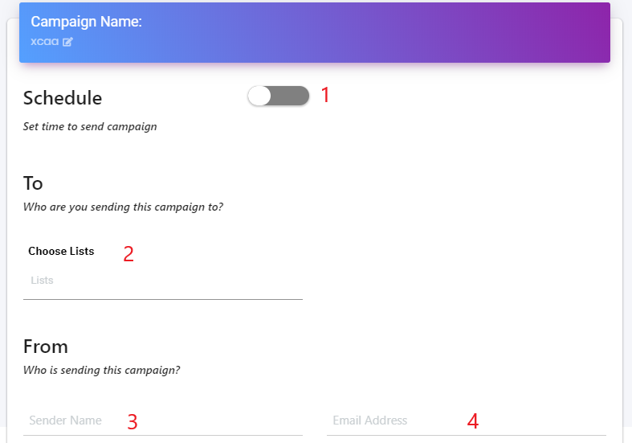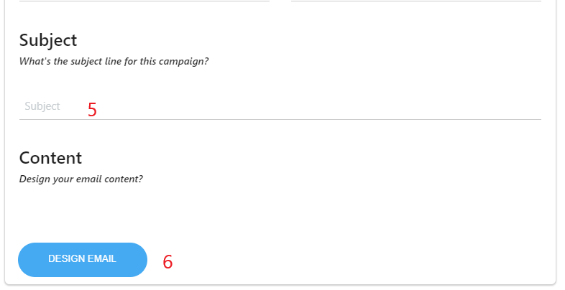

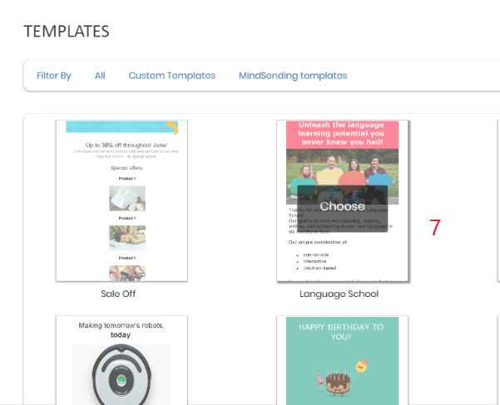

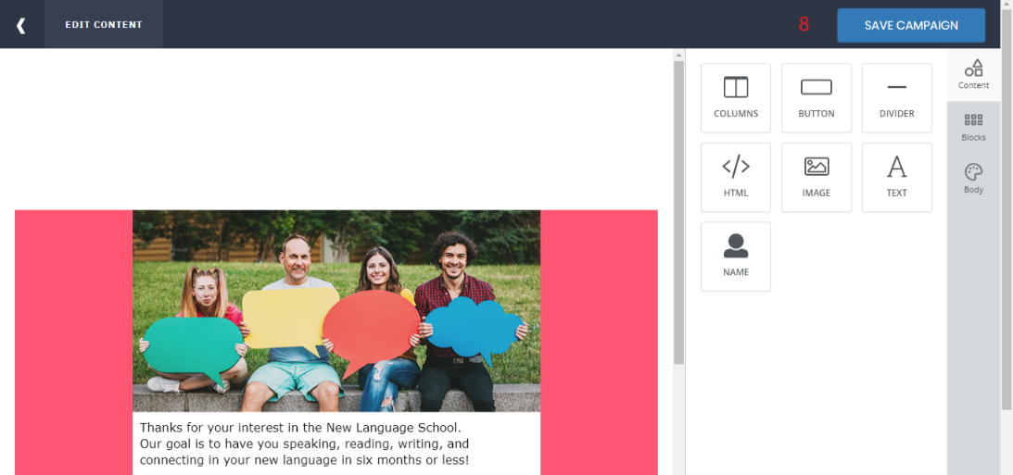

|  |  |
| --- | --- |
| **Step** | **Description** |
| 1 | Set up schedule |
| 2 | Choose list |
| 3 | Fill in sender name |
| 4 | Fill in email address |
| 5 | Fill in subject |
| 6 | Click “Design Email” button |
| 7 | Choose template |
| 8 | Save campaign |

# Appendix

1. **Spring Framework** *[Online]* Available: https:/spring.io/docs/reference.
2. **MySQL** *[Online]* Available: <https://dev.mysql.com/doc/>.
3. **ReactJS** *[Online]* Available: <https://reactjs.org/docs/getting-started.html>
4. **React Native** *[Online]* Available: <https://facebook.github.io/react-native/docs/getting-started>
5. **IntelliJ IDEA** *[Online]* Available: <https://www.jetbrains.com/idea/documentation/>
6. **WebStorm** *[Online]* Available: <https://www.jetbrains.com/webstorm/features/>
7. **Visual Studio Code** *[Online]* Available: <https://code.visualstudio.com/docs>
8. **Nodejs** *[Online]* Available: <https://nodejs.org/en/docs/>